EUROPEAN
COMMISSION

Brussels, XXX
[…] (2019) XXX draft
ANNEXES 1 to 8

ANNEXES
to the
Commission Delegated Regulation
supplementing Regulation (EU) 2017/1369
of the European Parliament and of the Council with regard to
energy labelling of household tumble driers
and repealing Commission Delegated Regulation (EU) 392/2012
ANNEX I
Definitions applicable for the annexes
For the purposes of the annexes, the following definitions shall apply:
- ‘Energy Efficiency Index’ (EEI) means the ratio of the weighted energy consumption to the standard cycle energy consumption;
- ‘programme’ means a series of operations that are pre-defined, and which are declared by the manufacturer importer or authorised representative as suitable for drying certain types of textile;
- ‘drying cycle’ means a complete drying process, as defined by the required programme, consisting of a series of different operations including heating and tumbling;
- ‘programme duration’ means the length of time beginning with the initiation of the programme selected, excluding any user programmed delay, until an end of programme indicator is activated, and the user has access to the load;
- ‘rated capacity’ means the maximum mass in kilograms, stated by the manufacturer importer or authorised representative in 0,5 kilogram intervals of dry textiles of a particular type, which can be treated in one drying cycle of a household tumble drier on the selected programme, when loaded in accordance with the manufacturer’s instructions;
- ‘partial load’ means half of the rated capacity of a household tumble drier for a given programme;
- ‘condensation efficiency’ means the ratio between the mass of moisture condensed by a condenser tumble drier and the mass of moisture removed from the load at the end of a cycle;
- ‘initial moisture content’ means for household tumble driers the amount of moisture contained in the load at the beginning of the drying phase;
- ‘remaining moisture content’ means for household tumble driers, the amount of moisture contained in the load at the end of the drying cycle;
- ‘quick response’ (QR) code means a matrix barcode included on the energy label of a product model that links to that model’s information in the public part of the product database;
- ‘off mode’ means a condition in which the equipment is connected to the mains power source and is not providing any function; the following shall also be considered as off mode:
      - conditions providing only an indication of off mode;
      - conditions providing only functionalities intended to ensure electromagnetic compatibility pursuant to Directive 2014/30/EU of the European Parliament and of the Council;
- ‘standby mode’ means a condition where the equipment is connected to the mains power source, and provides only the following functions, which may persist for an indefinite time:
      - reactivation function or reactivation function and a mere indication of enabled reactivation function, and/or
      - reactivation function through a connection to a network; and/or
      - information or status display, and/or
      - detection function for emergency measures;
- ‘network’ means a communication infrastructure with a topology of links, an architecture, including the physical components, organisational principles, communication procedures and formats (protocols);
- ‘wrinkle guard function’ means an operation of the household tumble drier after completion of a programme to prevent excessive wrinkle building in the laundry;
- ‘delay start’ means a condition where the user has selected a specified delay to the beginning of the cycle of the selected programme;
- ‘display mechanism' means any screen, including tactile screen, or other visual technology used for displaying internet content to users;
- 'nested display' means visual interface where an image or data set is accessed by a mouse click, mouse roll-over or tactile screen expansion of another image or data set;
- 'tactile screen' means a screen responding to touch, such as that of a tablet computer, slate computer or a smartphone;
- ‘alternative text' means text provided as an alternative to a graphic allowing information to be presented in non-graphical form where display devices cannot render the graphic or as an aid to accessibility such as input to voice synthesis applications.
- ‘standard cotton programme’ means the name of the programme declared by the manufacturer, importer or authorised representative as to be able to dry cotton laundry with an initial moisture content of the load of 60 % up to a remaining moisture content of the load of 0 %.

ANNEX II
Energy efficiency classes and condensation efficiency classes
- ENERGY EFFICIENCY CLASSES
The energy efficiency class of a household tumble drier shall be determined on the basis of its Energy Efficiency Index (EEI) as set out in Table 1.
The Energy Efficiency Index (EEI) of a household tumble drier shall be determined in accordance with point 1 of Annex IV.
Table 1
Energy efficiency classes
Energy efficiency class | Energy Efficiency Index
A (most efficient) | EEI ≤ 33
B | 33 < EEI ≤ 46
C | 46 < EEI ≤ 60
D | 60 < EEI ≤ 78
E | 78 < EEI ≤ 96
F | 96 < EEI ≤ 148
G (least efficient) | EEI>148

- CONDENSATION EFFICIENCY CLASSES
The condensation efficiency class of a condenser household tumble drier shall be determined on the basis of the weighted condensation efficiency (C_{t}) as set out in Table 2.
The weighted condensation efficiency (C_{t}) of a condenser household tumble drier shall be determined in accordance with point 2 of Annex IV.
Table 2
Condensation efficiency classes
Condensation efficiency class | Weighted condensation Efficiency C_{t}
A (most efficient) | C_{t} ≥ 94
B | 87 ≤ C_{t} < 94
C | 80 ≤ C_{t} < 87
D | C_{t} < 80

- ACOUSTIC AIRBORNE EMISSION CLASS
The acoustic airborne noise emission of a household tumble drier shall be determined as the weighted average value (L_{WA}) of the sound power in the standard cotton programme at full load during the drying phase expressed in dB(A) and rounded to the nearest integer.
The acoustic airborne noise emission class shall be determined on the basis of the weighted average value (L_{WA}) of the sound power as set out in Table 3
Table 3
Acoustic airborne noise emission class
Acoustic airborne emission class | Noise (dB(A))
A | L_{WA} ≤ 60
B | 60 < L_{WA} ≤ 64
C | 64 < L_{WA} ≤ 68
D | L_{WA} > 68

ANNEX III
Label
- LABEL FOR AIR-VENTED HOUSEHOLD TUMBLE DRIER
  - Label:

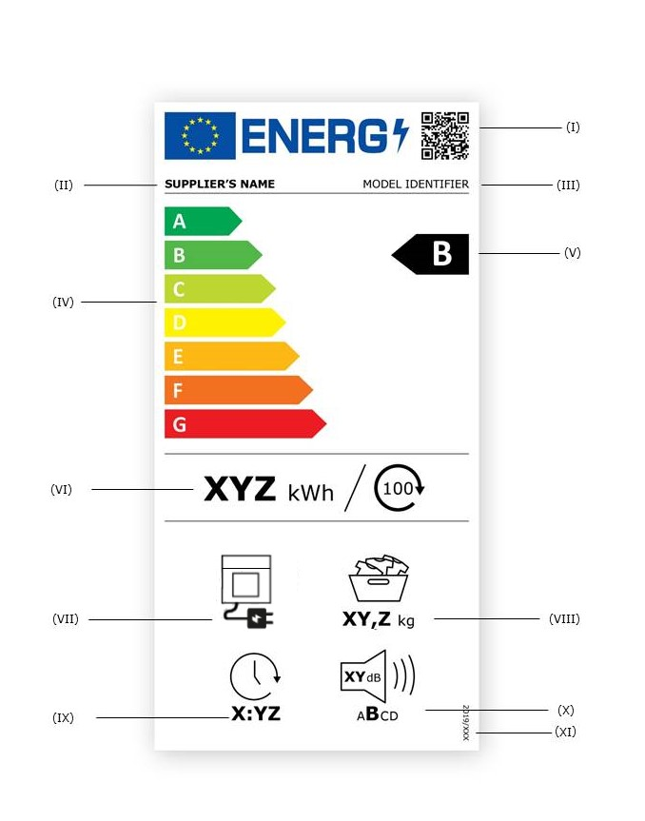

  - The following information shall be included in the label for air vented household tumble driers:
I QR code;
II supplier’s name or trade mark;
III model identifier;
IV the energy efficiency class determined in accordance with Annex II; the head of the arrow containing the energy efficiency class of the household tumble drier shall be placed at the same height as the head of the arrow of the relevant energy efficiency class;
V scale of energy efficiency classes from A to G;
VI weighted average energy consumption per 100 cycles in kWh, rounded to the nearest integer and calculated in accordance with Annex IV;
VII information on the type of household tumble drier;
VIII rated capacity, in kg, for the standard cotton programme at full load;
IX duration of the standard cotton programme at full load in hours and minutes [h:min] rounded to the nearest minute;
X airborne acoustic noise emission class of the drying phase of the standard cotton programme, with relevant logo and value in dB(A) re 1 pW and rounded to the nearest integer;
XI the number of this Regulation; that is ‘2022/XXX’ [OP - please insert the number of this Regulation in this point and in the right corner of the energy label].
  - The design of the label for air vented household tumble driers shall be in accordance with point 4 of this Annex. Where a model has been granted an ‘EU Ecolabel’ under Regulation (EC) No 66/2010 of the European Parliament and of the Council, a copy of the EU Ecolabel may be added.

- LABEL FOR CONDENSER HOUSEHOLD TUMBLE DRIER
  - Label:
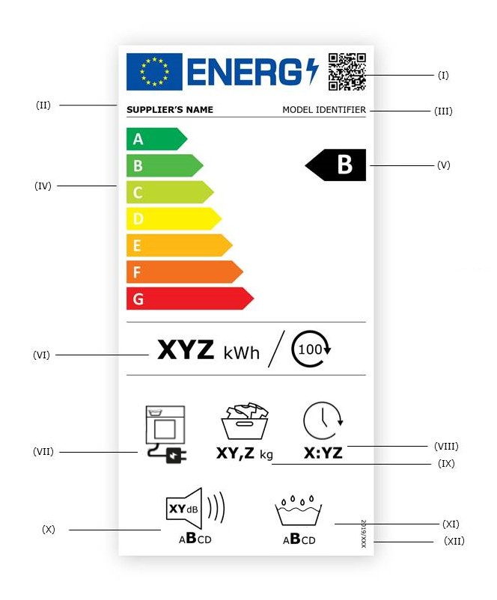

  - In addition to the information listed in point 1.2, the label for condenser household tumble driers shall include:
I QR code;
II supplier’s name or trade mark;
III model identifier;
IV the energy efficiency class determined in accordance with Annex II; the head of the arrow containing the energy efficiency class of the household tumble drier shall be placed at the same height as the head of the arrow of the relevant energy efficiency class;
V scale of energy efficiency classes from A to G;
VI weighted average energy consumption per 100 cycles in kWh, rounded to the nearest integer and calculated in accordance with Annex IV;
VII information on the type of household tumble drier;
VIII duration of the standard cotton programme at full load in hours and minutes [h:min] rounded to the nearest minute;
IX rated capacity, in kg, for the standard cotton programme at full load;
X airborne acoustic noise emission class of the drying phase of the standard cotton programme, with relevant logo and value in dB(A) re 1 pW and rounded to the nearest integer;
XI the condensation efficiency class in accordance with point 2 of Annex II;
XII the number of this Regulation; that is ‘2022/XXX’ [OP - please insert the number of this Regulation in this point and in the right corner of the energy label].
  - The design of the label for condenser household tumble driers shall be in accordance with point 4 of this Annex. Where a model has been awarded an ‘EU Ecolabel’ under Regulation (EC) No 66/2010, a copy of the EU Ecolabel may be added.
- LABEL FOR GAS-FIRED HOUSEHOLD TUMBLE DRIER
  - Label:
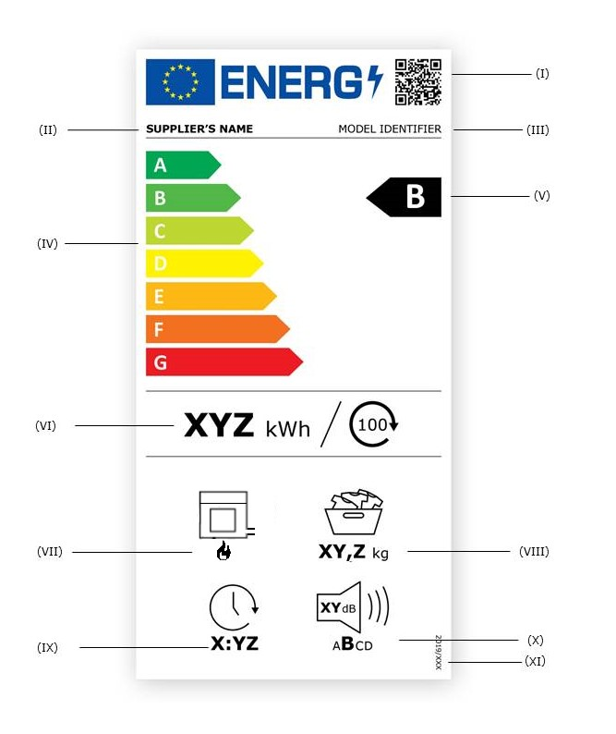

  - The information listed in point 1.2 shall be included in the label for gas fired household tumble driers.
  - The design of the label for gas fired household tumble driers shall be in accordance with point 4 of this Annex. Where a model has been awarded an ‘EU Ecolabel’ under Regulation (EC) No 66/2010, a copy of the EU Ecolabel may be added.

- LABEL DESIGN
  - For air vented household tumble driers, the design of the label shall be as in the figure below.

  - For condenser household tumble driers, the design of the label shall be as in the figure below.

  - For gas fired household tumble driers, the design of the label shall be as in the figure below.

Whereby
      - The label must be at least 96 mm wide and 192 mm high. Where the label is printed in a larger format, its content must nevertheless remain proportionate to the specifications above.
      - The background shall be 100% white.
      - The typefaces shall be Verdana and Calibri.
      - The dimensions and specifications of the elements in the label shall be as indicated in the label designs in points 4 of Annex III.
      - Colours shall be CMYK — cyan, magenta, yellow and black following this example: 0,70,100,0: 0 % cyan, 70 % magenta, 100 % yellow, 0 % black.
      - The label shall fulfil all of the following requirements (numbers refer to the figure above).
        - the colour of the energy logo shall be: 100,80,0,0;
        - the colours of the EU logo shall be as follows:
- the background: 100,80,0,0;
- the stars: 0,0,100,0;
        - the supplier’s name shall be in colour 100 % black and in Verdana Bold, 9 pt;
        - the A to G scale shall be as follows:
- the colour of the energy rating scale shall be 100 % white and in Calibri Bold font 19 pt;
- the colours of the energy rating scale arrows shall be as follows:
- A-class: 100,0,100,0;
- B-class: 70,0,100,0;
- C-class: 30,0,100,0;
- D-class: 0,0,100,0;
- E-class: 0,30,100,0;
- F-class: 0,70,100,0;
- G-class: 0,100,100,0;
        - the QR code shall be 100 % black;
        - the model identifier shall be 100 % black and in Verdana Regular font 9 pt;
        - the divider shall be 80 mm wide and have a weight of 0,5 pt. The colour of the divider shall be 100 % black;
        - the colour of the letter of the energy efficiency class shall be in 100 % white and in Calibri bold font 33 pt. The rating scale arrow and the energy efficiency class arrow shall be positioned in such a way that their tips are aligned. The letter in the efficiency class arrow shall be positioned in the centre of the rectangular part of the arrow;
        - the weighted energy consumption value per 100 cycles shall be in Verdana Bold font 26 pt; ‘kWh/’ shall be in Verdana Regular font 20 pt. The text shall be centred in the column and in 100 % black;
        - the pictograms shall be as follows:
- the colour shall be 100 % black;
- the value (rated capacity in Kg, W_{t} or programme duration) under the pictogram shall be in Verdana Bold font 16 pt with the unit in Verdana Regular font 12 pt, and it shall be centred under the pictogram, in 100 % black;
        - the Regulation number shall be 100 % black and in Verdana Bold, 6 pt.

ANNEX IV
Measurement methods and calculations
For the purposes of compliance and verification of compliance with the requirements of this Regulation, measurements and calculations shall be made using harmonised standards the reference numbers of which have been published for this purpose in the Official Journal of the European Union, or other reliable, accurate and reproducible methods, which takes into account the generally recognised state-of-the-art, and in line with the following provisions.
The standard cotton programme shall be used for the measurement and calculation of the Energy Efficiency Index (EEI), Condensation Efficiency Index and the programme duration. The energy consumption, condensation efficiency and programme duration shall be measured concurrently.
The duration of the standard cotton programme at full load and at partial load is expressed in minutes and rounded to the nearest minute.
Acoustic airborne noise emissions (L_{WA}) are measured in dB(A) with respect to 1 pW and rounded to the nearest integer.

ENERGY EFFICIENCY INDEX
For the calculation of the energy efficiency index (EEI) of a household tumble drier model, the weighted average energy consumption per cycle of a household tumble drier for the standard cotton programme at full and partial load is compared to its standard energy consumption per cycle.
  - The energy efficiency index (EEI) is calculated as follows and rounded to one decimal place:
$$EEI=\frac{E_{tC}}{{SE}_{C}}×100$$

where:
- E_{tC} = weighted average energy consumption per cycle of the household tumble drier during active mode,
- SE_{C} = standard energy consumption per cycle of the household tumble drier.
  - The standard energy consumption per cycle (SE_{C}) is calculated in kWh as follows and rounded to two decimal places:
- for all household tumble driers that are not air-vented:
$${SE}_{C}=0,44×c^{0,75}$$
- for air-vented household tumble driers:
$${SE}_{C}=0,44×c^{0,75}-\left(1-\frac{T_{t}}{60}×0,083\right)$$
where:
- c is the rated capacity of the household tumble drier for the standard cotton programme,
- T_{t} is the weighted programme duration for the standard cotton programme.
  - The weighted average energy consumption per cycle (E_{tC}) is calculated in kWh as follows and rounded to two decimal places:
$$E_{tC}=0,24×E_{dry}+0,76×E_{dry½}$$
where:
- E_{dry} = energy consumption of the standard cotton programme at full load, in kWh and rounded to two decimal places,
- E_{dry½} = energy consumption of the standard cotton programme at partial load, in kWh and rounded to two decimal places.
The weighted energy consumption for 100 cycles (E_{tC100}) is calculated in kWh as follows and rounded to 0 decimal places:
$$E_{tC100}=E_{tC}×100$$
where:
- E_{tC100} is the weighted energy consumption for 100 cycles of the household tumble drier.
  - The weighted programme duration (Tt) for the standard cotton programme is calculated in minutes as follows and rounded to the nearest minute:
$$T_{t}=0,24×T_{dry}+0,76×T_{dry½}$$
where:
- T_{dry} = programme duration for the standard cotton programme at full load, in minutes and rounded to the nearest minute,
- T_{dry½} = programme duration for the standard cotton programme at partial load, in minutes and rounded to the nearest minute.
  - For gas-fired household tumble driers, the energy consumption for the standard cotton programme at full and partial load is calculated in kWh, rounded to two decimal places, as:
$$E_{dry}=\frac{{Eg}_{dry}}{f_{g}}+{Eg}_{dry,a}$$

$$E_{dry½}=\frac{{Eg}_{dry½}}{f_{g}}+{Eg}_{dry½,a}$$
where:
- Eg_{dry} = gas consumption of the standard cotton programme at full load, in kWh and rounded to two decimal places,
- Eg_{dry½} = gas consumption of the standard cotton programme at partial load, in kWh and rounded to two decimal places,
- Eg_{dry,a} = auxiliary electricity consumption of the standard cotton programme at full load, in kWh and rounded to two decimal places,
- Eg_{dry½,a} = auxiliary electricity consumption of the standard cotton programme at partial load, in kWh and rounded to two decimal places,
- f_{g} = 2,1.

WEIGHTED CONDENSATION EFFICIENCY
The condensation efficiency of a programme is the ratio between the mass of moisture condensed and collected in the container of a condenser household tumble drier and the mass of moisture removed from the load by the programme, the latter being the difference between the mass of the wet test load before drying and the mass of the test load after drying. For calculating the weighted condensation efficiency, the average condensation efficiency of the standard cotton programme at both full and partial load is considered.
The weighted condensation efficiency (C_{t}) of a programme is calculated as a percentage and rounded to the nearest whole percent as:
$$C_{t}=0,24×C_{dry}+0,76×C_{dry½}$$
where:
- C_{dry} = average condensation efficiency of the standard cotton programme at full load,
- C_{dry½} = average condensation efficiency of the standard cotton programme at partial load.
The average condensation efficiency C is calculated from the condensation efficiencies of test runs and expressed as a percentage:
$$C=\frac{1}{\left(n-1\right)}\sum_{J=2}^{n}{\left(\frac{W_{Wj}}{W_{i}-W_{f}}×100\right)}$$
where:
- n is the number of test runs, comprising at least four valid test runs for the selected programme,
- j is the test run number,
- W_{wj} is the mass of water collected in the condenser reservoir during test run j,
- W_{i} is the mass of the wet test load before drying,
- W_{f} is the mass of the test load after drying.

LOW POWER MODES
The power consumption of the off mode (P_{o}), standby mode (P_{sm}), networked standby mode (P_{nsm}), and where applicable delay start (P_{ds}) are measured. The measured values are expressed in W and rounded to two decimal places.
During measurements of the power consumption in low power modes, the following shall be checked and recorded:
- the display or not of information;
- the activation or not of a network connection.
If the household tumble drier provides for a wrinkle guard function, this operation shall be interrupted by opening the household tumble drier’s door, or any other appropriate intervention 15 minutes before the measurement of energy consumption.

ACOUSTIC AIRBORNE NOISE EMMISSION
The acoustic airborne noise emission of the drying phase of household tumble driers shall be calculated for the standard cotton programme at full load, using harmonised standards the reference numbers of which have been published for this purpose in the Official Journal of the European Union, or other reliable, accurate and reproducible methods, which take into account the generally recognised state-of-the-art, and rounded to the nearest integer.

ANNEX V
Product information sheet
Pursuant to point 1(b) of Article 3, the supplier shall be enter the information into the product database as set out in Table 4.
The user manual or other literature provided with the product shall clearly indicate the link to the model in the product database as a human-readable Uniform Resource Locator (URL) or as QR code or by providing the product registration number.

Table 4
Content, order and format of the product information sheet
Supplier’s name or trade mark:
Supplier’s address^{b}:
Model identifier:
Type of tumble drier |  | [Air-vented, condenser, gas-fired]
General product parameters:
Parameter | Value |  |  | Parameter | Value
Rated capacityª (kg) | x,x |  |  | Dimensions in cm | Height | x
 |  |  |  |  | Width | x
 |  |  |  |  | Depth | x
EEIª | x |  |  | Energy efficiency classª | [A/B/C/D/E/F/G]^{c}
Energy efficiency indexª | x,xx |  |  | Condensation efficiency (%)ª  (if applicable) | xx
For electrical mains operated:  Energy consumption in kWh per cycle, based on the standard cotton programme. Actual energy consumption will depend on how the appliance is used. | x,xxx |  |  | For gas-fired: Gas consumption in kWh per cycle, based on the standard cotton programme. Actual energy consumption will depend on how the appliance is used. | x,xxx
Programme durationª (hours:minutes) | Rated capacity |  | xxx | Type | [built-in/free-standing]
 | Half |  | xxx
Acoustic airborne noise emission in the drying phaseª (dB(A) re 1 pW) | x
Off-mode (W) | x,xx |  |  | Standby mode (W) | x,xx
Delay start (W) (if applicable) | x,xx |  |  | Networked standby (W) (if applicable) | x,xx
For household tumble driers equipped with a heat pump, the chemical name of the refrigerant gas used.
Additional information:
Weblink to the supplier’s website, where the information in point 9 of Annex II to Regulation [OP – please insert Regulation number of the Ecodesign Regulation]^{b} is found:
ª for the standard cotton programme
^{b} changes to these items shall not be considered relevant for the purposes of point 4 of Article 4 of Regulation (EU) 2017/1369.
^{c} if the product database automatically generates the definitive content of this cell the supplier shall not enter these data.

ANNEX VI
Technical documentation
- For electric mains operated household tumble driers, the technical documentation referred to in Article 3(d) shall include:
        - information as set out in point 1 of Annex V;
        - information as set out in Table 5;
Table 5
Information to be included in the technical documentation for electric mains operated household tumble driers
PARAMETER | UNIT | VALUE
Rated capacity for the standard cotton programme, at 0,5 kg intervals (c) | kg | X,X
Energy consumption of the standard cotton programme at full load (E_{dry}) | kWh/cycle | X,XXX
Energy consumption of the standard cotton programme at partial load (E_{dry,½}) | kWh/cycle | X,XXX
Weighted average energy consumption of the standard cotton programme (E_{tC}) | kWh/cycle | X,XX
Standard energy consumption of the standard cotton programme (SE_{C}) | kWh/cycle | X,XX
Energy Efficiency Index (EEI) | - | X,X
Programme time for the standard cotton programme at full load (T_{dry}) | min | XXX
Programme time for the standard cotton programme at partial load (T_{dry½}) | min | XXX
Weighted programme time for the standard cotton programme (T_{t}) | min | XXX
Average condensation efficiency of the standard cotton programme at full load (C_{dry}) | % | XX
Average condensation efficiency of the standard cotton programme at partial load (C_{dry}) | % | XX
Weighted average condensation efficiency of the standard cotton programme (C_{t}) | % | XX
Airborne acoustical noise emissions during the standard cotton programme | dB(A) re 1 pW | X
Power consumption in ‘off mode’ (P_{o}) | W | X,XX
Power consumption in ‘standby mode’ (P_{sm}) | W | X,XX
Does ‘standby mode’ include the display of information? | - | Yes/No
Power consumption in ‘standby mode’ (P_{sm}) in condition of networked standby (if applicable) | W | X,XX
Power consumption in ‘delay start’ (P_{ds}) (if applicable) | W | X,XX

(c) where appropriate, the references of the harmonised standards applied;
(d) where appropriate, the other technical standards and specifications used;
(e) the details and the results of calculations performed in accordance with Annex IV;
(f) a list of all equivalent models including the model identifier.

2. For gas-fired household tumble driers, the technical documentation referred to Article 3 (c) shall include:
(a) information as set out in point 1 of Annex V;
(b) information as set out in Table 6;

Table 6
Information to be included in the technical documentation for gas-fired household tumble driers
PARAMETER | UNIT | VALUE
Rated capacity for the standard cotton programme, at 0,5 kg intervals (c) | kg | X,X
Gas consumption of the standard cotton programme at rated capacity (E_{gdry}) | kWh/cycle | X,XXX
Gas consumption of the standard cotton programme at half rated capacity (E_{gdry,½}) | kWh/cycle | X,XXX
Auxiliary electricity consumption of the standard cotton programme at full load | kWh/cycle | X,XX
Auxiliary electricity consumption of the standard cotton programme at partial load | kWh/cycle | X,XX
Weighted average energy consumption of the standard cotton programme (E_{tC}) | kWh/cycle | X,XX
Standard energy consumption of the standard cotton programme (SE_{C}) | kWh/cycle | X,XX
Energy Efficiency Index (EEI) | - | X,X
Programme time for the standard cotton programme at full load (T_{dry}) | min | XXX
Programme time for the standard cotton programme at partial load (T_{dry½}) | min | XXX
Weighted programme time for the standard cotton programme (T_{t}) | min | XXX
Average condensation efficiency of the standard cotton programme at full load (C_{dry}) | % | XX
Average condensation efficiency of the standard cotton programme at partial laod (C_{dry}) | % | XX
Weighted average condensation efficiency of the standard cotton programme (C_{t}) | % | XX
Airborne acoustical noise emissions during the standard cotton programme | dB(A) re 1 pW | X
Power consumption in ‘off mode’ (P_{o}) | W | X,XX
Power consumption in ‘standby mode’ (P_{sm}) | W | X,XX
Does ‘standby mode’ include the display of information? | - | Yes/No
Power consumption in ‘standby mode’ (P_{sm}) in condition of networked standby (if applicable) | W | X,XX
Power consumption in ‘delay start’ (P_{ds}) (if applicable) | W | X,XX
(c) where appropriate, the references of the harmonised standards applied;
(d) where appropriate, the other technical standards and specifications used;
(e) the details and the results of calculations performed in accordance with Annex IV;
(f) a list of all equivalent models including the model identifier.

- Where the information included in the technical documentation for a particular household tumble drier model has been obtained by any of the following methods, or both:
- from a model that has the same technical characteristics relevant for the technical information to be provided but is produced by a different supplier,
- by calculation on the basis of design or extrapolation from another model of the same or a different supplier,
the technical documentation shall include the details of such calculation, the assessment undertaken by suppliers to verify the accuracy of the calculation and, where appropriate, the declaration of identity between the models of different suppliers.

ANNEX VII
Information to be provided in visual advertisements, in technical promotional material in distance selling and in telemarketing, except distance selling on the internet
- In visual advertisements for household tumble driers, for the purposes of ensuring conformity with the requirements laid down in point 1(e) of Article 3 and point (c) of Article 4, the energy efficiency class and the range of energy efficiency classes available on the label shall be shown as set out in point 4 of this Annex.
- In technical promotional material or other promotional material for household tumble driers, for the purposes of ensuring conformity with the requirements laid down in point 1(f) of Article 3 and point (d) of Article 4, the energy efficiency class and the range of energy efficiency classes available on the label shall be shown as set out in point 4 of this Annex.
- Any paper based distance selling of household tumble driers must show the energy efficiency class and the range of energy efficiency classes available on the label as set out in point 4 of this Annex.
- The energy efficiency class and the range of energy efficiency classes shall be shown, as indicated in Figure 1, with:
      - an arrow containing the letter of the energy efficiency class, in white and in a font size at least equivalent to that of the price, when the price is shown; and
      - the colour of the arrow matching the colour of the energy efficiency class; and
      - the range of available energy efficiency classes in 100 % black; and
      - the size shall be such that the arrow is clearly visible and legible. The letter in the energy efficiency class arrow shall be positioned in the centre of the rectangular part of the arrow, with a border of 0,5 pt in black placed around the arrow and the letter of the energy efficiency class.
Figure 1: Coloured left/right arrow example, with range of energy efficiency classes indicated
By derogation, if the visual advertisements, technical promotional material or paper based distance selling is printed in black and white, the colour of the arrow can be in black and white in that visual advertisements, technical promotional material or paper based distance selling.
- Telemarketing based distance selling must specifically inform the customer of the energy classes of the product and of the range of energy classes available on the label, and that the customer can access the label and the product information sheet through the product database website, or by requesting a printed copy.
For all the situations mentioned in points 1 to 3 and 5, it must be possible for the customer to obtain, on request, a printed copy of the label and the product information sheet.

ANNEX VIII
Information to be provided in the case of distance selling through the internet
- The appropriate label made available by suppliers in accordance with point 1(g) of Article 3 shall be shown on the display mechanism in proximity to the price of the product. The size shall be such that the label is clearly visible and legible and shall be proportionate to the size specified in Annex III. The label may be displayed using a nested display, in which case the image used for accessing the label shall comply with the specifications laid down in point 2 of this Annex. If nested display is applied, the label shall appear on the first mouse click, mouse roll-over or tactile screen expansion on the image.
- The image used for accessing the label in the case of nested display shall:
      - be an arrow in the colour corresponding to the energy efficiency class of the product on the label; and
      - indicate the energy efficiency class of the product on the arrow in white in a font size equivalent to that of the price; and
      - have one of the following two formats, and its size shall be such that the arrow is clearly visible and legible. The letter in the energy efficiency class arrow shall be positioned in the centre of the rectangular part of the arrow:
Figure 2: Coloured left/right arrow example, with range of energy efficiency classes indicated
- In the case of nested display, the sequence of display of the label shall be as follows:
      - the images referred to in point 2 of this Annex shall be shown on the display mechanism in proximity to the price of the product;
      - the images shall link to the label as set out in Annex III;
      - the label shall be displayed after a mouse click, mouse roll-over or tactile screen expansion on the image;
      - the label shall be displayed by pop up, new tab, new page or inset screen display;
      - for magnification of the label on tactile screens, the device conventions for tactile magnification shall apply;
      - the label shall cease to be displayed by means of a close option or other standard closing mechanism;
      - the alternative text for the graphic, to be displayed on failure to display the label, shall be the energy efficiency classes of the product in a font size equivalent to that of the price.
- The electronic product information sheet made available by suppliers in accordance with point 1(h) of Article 3 shall be shown on the display mechanism in proximity to the price of the product. The size shall be such that the product information sheet is clearly visible and legible. The product information sheet may be displayed using a nested display or by referring to the product database, in which case the link used for accessing the product information sheet shall clearly and legibly indicate ‘Product information sheet’. If a nested display is used, the product information sheet shall appear on the first mouse click, mouse roll-over or tactile screen expansion on the link.

ANNEX IX
Verification procedure for market surveillance purposes
The verification tolerances set out in this Annex relate only to the verification of the declared parameters by Member State authorities and shall not be used by the supplier as an allowed tolerance to establish the values in the technical documentation. The values and classes on the label or in the product fiche shall not be more favourable for the supplier than the values reported in the technical documentation.
Where a model has been designed to be able to detect it is being tested (e.g. by recognising the test conditions or test cycle), and to react specifically by automatically altering its performance during the test with the objective of reaching a more favourable level for any of the parameters specified in this Regulation or included in the technical documentation or included in any of the documentation provided, the model and all equivalent models shall be considered not compliant.
When verifying the compliance of a product model with the requirements laid down in this Delegated Regulation, the authorities of Member States shall apply the following procedure:
1. The Member State authorities shall verify one single unit of the model.
2. The model shall be considered to comply with the applicable requirements if:
      - the values given in the technical documentation pursuant to Article 3(3) of Regulation (EU) 2017/1369 (declared values), and, where applicable, the values used to calculate these values, are not more favourable for the supplier than the corresponding values given in the test reports; and
      - the values published on the label and in the product information sheet are not more favourable for the supplier than the declared values, and the indicated energy efficiency class and the condensation efficiency class (where applicable) are not more favourable for the supplier than the class determined by the declared values; and
      - when the Member State authorities test the unit of the model, the determined values (the values of the relevant parameters as measured in testing and the values calculated from these measurements) comply with the respective verification tolerances as given in Table 7.
3. If the results referred to in points 2(a) or (b) are not achieved, the model and all equivalent models shall be considered not to comply with this Regulation.
4. If the result referred to in point 2(c) is not achieved, the Member State authorities shall select three additional units of the same model for testing. As an alternative, the three additional units selected may be of one or more equivalent models.
5. The model shall be considered to comply with the applicable requirements if for these three units, the arithmetical mean of the determined values complies with the respective tolerances given in Table 7.
6. If the result referred to in point 5 is not achieved, the model and all equivalent models shall be considered not to comply with this Regulation.
7. The Member State authorities shall provide all relevant information to the authorities of the other Member States and to the Commission without delay after a decision being taken on the non-compliance of the model according to points 3 and 6.

The Member State authorities shall use the measurement and calculation methods set out in Annex IV.
The Member State authorities shall only apply the verification tolerances that are set out in Table 7 and shall only use the procedure described in points 1 to 7 for the requirements referred to in this Annex. For the parameters in Table 7 no other tolerances, such as those set out in harmonised standards or in any other measurement method, shall be applied.
Table 7
Verification tolerances
Parameter | Verification tolerances
E_{dry} and E_{dry½} | The determined value* shall not exceed the declared value of E_{dry} and E_{dry½} by more than 6 %.
Eg_{dry} and Eg_{dry½} | The determined value* shall not exceed the declared value of Eg_{dry} and Eg_{dry½} by more than 6 %.
Eg_{dry,a} and Eg_{dry½,a} | The determined value* shall not exceed the declared value of Eg_{dry,a} and Eg_{dry½,a} by more than 6 %.
Weighted average energy consumption per cycle (E_{tC}) | The determined value* shall not exceed the declared value of E_{t} by more than 6 %.
Weighted condensation efficiency (C_{t}) | The determined value* shall not be less than the declared value of C_{t} by more than 6 %.
T_{dry} and T_{dry½} | The determined value* shall not exceed the declared value of T_{dry} and T_{dry½} by more than 6 %.
Weighted programme time (T_{t}) | The determined value* shall not exceed the declared values of T_{t} by more than 6 %.
Power consumption in off mode (Po) | The determined value* of power consumption Po shall not exceed the declared value by more than 0,10 W.
Power consumption in standby mode (Psm) | The determined value* of power consumption P_{sm} shall not exceed the declared value by more than 10 % if the declared value is higher than 1,00 W, or by more than 0,10 W if the declared value is lower than or equal to 1,00 W.
Power consumption in delay start mode (Pds) | The determined value* of power consumption P_{ds} shall not exceed the declared value by more than 10 % if the declared value is higher than 1,00 W, or by more than 0,10 W if the declared value is lower than or equal to 1,00 W.
Airborne acoustical noise emissions | The determined value* shall not exceed the declared value by more than 2 dB re 1 pW.
* In the case of three additional units tested as prescribed in point 4, the determined value means the arithmetical mean of the values determined for these three additional units.

Directive 2014/30/EU of the European Parliament and of the Council of 26 February 2014 on the harmonisation of the laws of the Member States relating to electromagnetic compatibility (OJ L 96, 29.3.2014, p. 79).
OJ L 27, 30.1.2010, p. 1.

