DRAFT ANNEXES
of
COMMISSION DELEGATED REGULATION (EU) …/...
supplementing Regulation (EU) 2017/1369 of the European Parliament and of the Council with regard to energy labelling of household refrigerating appliances and low noise refrigerating appliances
repealing
Regulation (EU) No 1060/2010 with regard to energy labelling of household refrigerating appliances

This draft has not been adopted or endorsed by the European Commission. Any views expressed are the preliminary views of the Commission services and may not in any circumstances be regarded as stating an official position of the Commission. The information transmitted is intended only for the Member State or entity to which it is addressed for discussions and may contain confidential and/or privileged material.

ANNEX I
Definitions applicable for Annexes I to X
In addition to the definition set out in Regulation (EU) 2017/1369 and the definitions set out in Article 2 of this Regulation, the following definitions apply:
- ‘model identifier’ means the code, usually alphanumeric, which distinguishes a specific refrigerating appliance model from other models with the same trade mark or supplier’s name;
- ‘dedicated appliance’ means a refrigerating appliance with only one type of compartment;
- 'through-the-door device' means a device that dispenses chilled or frozen load on demand from a household refrigerating appliance, through an opening in its external door and without opening that external door. Examples are ice-cube dispensers or chilled water dispensers;
- ’variable temperature compartment' means a compartment intended for use as two (or more) alternative compartment types (e.g. a compartment that can be either a fresh food compartment or freezer compartment) and which is capable of being set by a user to continuously maintain the operating temperature range applicable for each compartment type claimed. A compartment intended for use as a single compartment type that can also meet storage conditions of other compartment types (e.g. a chill compartment that may also fulfil zero-star requirements) is not a variable temperature compartment;
- 'two-star section' means part of a three-star or four-star compartment which does not have its own individual access door or lid and in which the temperature is not warmer than −12 °C;
- ‘minimum temperature’ (T_{min}) means the minimum temperature inside a compartment during testing and relates to the minimum temperature for testing energy consumption (average over time and over a set of sensors) or the instantaneous values over the test period, as set out in Annex IV, Table 3;
- ‘maximum temperature’ (T_{max}) means the maximum temperature inside a compartment during testing and relates to the maximum temperature for testing energy consumption (average over time and over a set of sensors) or the instantaneous values over the test period, as set out in Annex IV, Table 3;
- ‘4-star’ means a rating for a freezer compartment that fulfils the storage conditions indicated in Annex IV, Table 3 and also fulfils a minimum specific freezing capacity requirement that entails that the temperature of the light load is brought down from +25 to −18 °C within 24 hours. If the minimum freezing capacity cannot be guaranteed at all times within the ambient temperature operating range indicated by the manufacturer or importer, a 4-star rating does not apply;
- ‘defrost and recovery period’ means the period from the initiation of a defrost control cycle until stable operating conditions are established; ‘total average steady state power consumption’ (P_{ss}) means the average power consumption in steady state conditions expressed in W, as determined in accordance with Annex IV;
- ‘incremental defrost and recovery energy consumption’ (ΔE_{d-f}) means the extra average energy consumption for a defrost and recovery operation expressed in Wh, as determined in accordance with Annex IV;
- ‘auto-defrost’ means a feature by which compartments are defrosted without user intervention to initiate the removal of frost accumulation at all temperature-control settings or to restore normal operation, and the disposal of the defrosted water is automatic;
- ‘defrost interval’ (t_{d-f}) means the representative average interval between the time of activation of the defrost heater, or the time of deactivation of the compressor if there is no defrost heater, in two subsequent defrost and recovery cycles expressed in h;
- 'average power consumption' (P) means the average rate of energy consumption of a refrigerating appliance for a specific test condition or operation expressed in Watts;
- ‘temperature control cycle’ (TCC) means definite repetitive swings in temperature caused by operation of a temperature control device (on/off or otherwise). The period of a temperature control cycle is the time between a control event and its repetition on the next cycle. Where the control events cannot be discerned, the period of a temperature control cycle is the time between two successive temperature warmest points or two successive temperature coldest points. If no repetitive pattern can be distinguished, ‘fixed time slices’ can be used to establish whether steady state conditions are fulfilled;
- ‘fixed time slice’ means a fixed length period of no less than a minimum number of hours as set out in Annex III.3(2) that may be used as an alternative to using TCCs in defining a block of test data, e.g. in case there are no discernible changes in temperature or power consumption over time;
- ‘combi appliance’ means a refrigerating appliance that has more than one compartment type, except in the case of a freezer (3- or 4-star) compartment featuring also a two-star section or sub-compartment;
- ‘standard annual energy consumption’ (SAE) means the reference annual energy consumption of a refrigeration appliance expressed in kWh, as determined in accordance with Annex IV;
- ‘manual defrost’ means not having an auto-defrost feature;
- ‘standard annual energy consumption’ (SAE) means the reference annual energy consumption of a refrigeration appliance expressed in kWh, as determined in accordance with Annex IV;
- 'daily energy consumption' (E_{daily}) means the electricity used by a refrigerating appliance over 24 hours at reference conditions expressed in kWh/24h, as determined in accordance with Annex IV;
- ‘thermodynamic factor’ (r_{c}) means the temperature difference between the target temperature T_{c} of compartment c and the reference ambient temperature at +24 °C, expressed as a ratio of the same difference for a fresh food compartment at +4 °C, following the expression r_{c} = (24−T_{c})/20;
- 'M_{c'} and 'N_{c}' are parameters that take into account the volume-dependence of the energy use, with values as set out in Annex IV, Table 4;
- 'auto-defrost factor' (A_{c}) means a compensation factor for frozen compartments, with values as set out in Annex IV, Table 4;
- 'built-in factor' (B_{c}) means a compensation factor for built in appliances, with values as set out in Annex IV, Table 4;
- 'combi factor’ (C) means a compensation factor for the energy consumption related to controlling the cooling of multiple compartment types; with values as set out in Annex IV, Table 4;
- 'door heat loss factor' (D) means a compensation factor for combi-appliances with more than two external doors with values as set out in Annex IV, Table 4;
- 'load factor' (L) means a compensation factor for the extra cooling load from introducing warm foodstuffs beyond what is already anticipated through the higher average ambient temperature for testing with values as set out in Annex IV, Table 4;
- ‘refrigerator-freezer’ means a combi that has at least one freezer compartment and one or more unfrozen or chill compartments, of which one fresh food compartment;
- 'temperature rise time' means the time taken, after the operation of the refrigerated system has been interrupted, for the temperature in a 3- or 4-star compartment to increase from −18 to −9 °C expressed in h;
- ‘climate class’ is the range of ambient temperatures in which the appliances are intended to be used, and for which the required storage temperatures specified in Table 1 are to be met. There are four climate classes (with their acronym and ambient temperature range): ‘Extended Temperate’ (‘SN’ for +10 to +32 °C), ‘Temperate’ (‘N’ for +16 to +32 °C), ‘Subtropical’(‘ST’ for +16 to +38 °C) and ‘Tropical’ (‘T’ for +16 to +43 °C);
- ‘built-in appliance’ means any household refrigerating appliance that is designed, intended, tested and marketed exclusively:
- to be installed in cabinetry or totally encased (top, bottom, sides and back) by panels, and
- to be securely fastened to the sides, top or floor of the cabinetry or panels, and
- to be equipped with an integral factory-finished face or to be fitted with a custom front panel;
- 'specific freezing capacity' (x) means the rate of heat extraction by an appropriately loaded refrigeration system, calculated as 12 times the light load weight, divided by the freezing time to bring the temperature of the light load from +25 to −18 °C at an ambient temperature of 25 °C expressed in kg/12h. The light load weight is 3,5 kg per 100 litre of freezer volume, and should be at least 2,0 kg;
- ‘winter switch’ means a control feature for a refrigerator-freezer with one compressor and one thermostat in the fresh food compartment, consisting of an appropriate sensory and switching device that activates or de-activates an artificial heat load in the fresh food compartment in order to guarantee, even if it would not be required for the fresh food compartment, that the compressor continues working to maintain the proper minimum temperature in the freezer compartment;
- 'fast freeze' means a reversible feature, to be activated by the end-user according to the manufacturer's instructions, which decreases the storage temperature of the freezer or freezer compartment to achieve a faster freezing of unfrozen foodstuffs;
- 'display mechanism' means any screen, including tactile screen, or other visual technology used for displaying internet content to users;
- 'nested display' means visual interface where an image or data set is accessed by a mouse click, mouse roll-over or tactile screen expansion of another image or data set;
- 'tactile screen' means a screen responding to touch, such as that of a tablet computer, slate computer or a smartphone;
- 'alternative text' means text provided as an alternative to a graphic allowing information to be presented in non- graphical form where display devices cannot render the graphic or as an aid to accessibility such as input to voice synthesis applications.

ANNEX II
Energy efficiency classes
The energy efficiency class of a household and low-noise refrigerating appliance shall be determined on the basis of its Energy Efficiency Index (EEl) as set out in Table 1.
Table 1
Energy efficiency classes
Energy efficiency class | Energy efficiency index
A | EEI ≤ 41
B | 41< EEI ≤ 51
C | 51< EEI ≤ 64
D | 64 < EEI ≤ 80
E | 80 < EEI ≤ 100
F | 100 < EEI ≤ 125
G | EEI > 125

The Energy Efficiency Index of a household or low-noise refrigerating appliance shall be determined in accordance with Annexes IV.

ANNEX III
Label
- Label 1
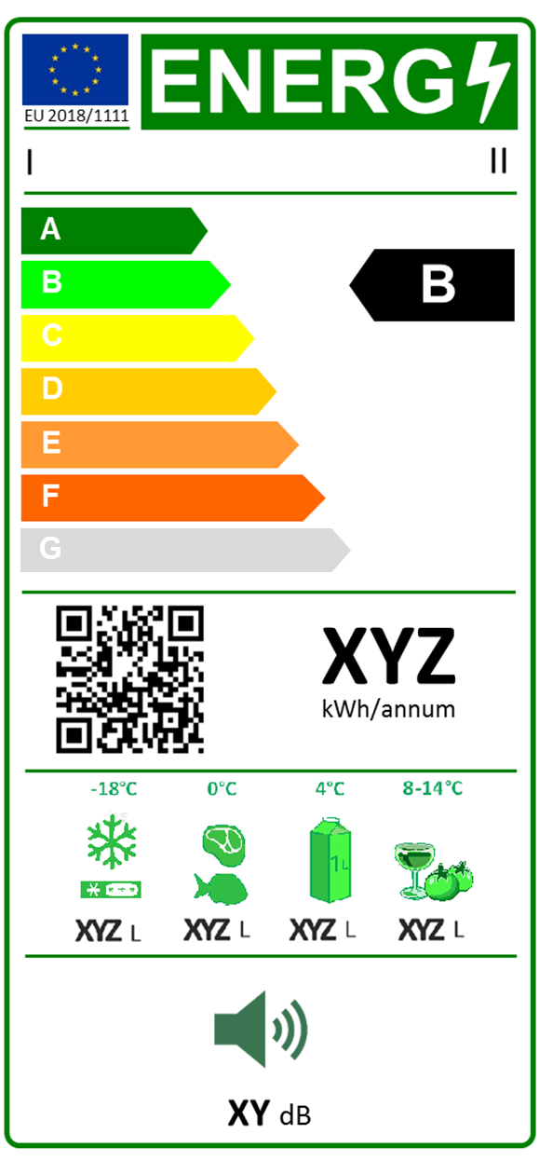
  - For household refrigerating appliances, except wine storage appliances:
I
II

III

IV
V

VI
VII
VIII
IX

X

The following information shall be included in the label:
I. supplier's name or trade mark;
II. supplier's model identifier;
III. the energy efficiency class determined in accordance with Annex II; the head of the arrow containing the energy efficiency class of the household refrigerating appliance shall be placed at the same height as the head of the arrow of the relevant energy efficiency class;
IV. QR-code linking to model information on the supplier’s website and/or the EU product database;
V. annual energy consumption in kWh per year, AE rounded up to the nearest integer and calculated in accordance with Annex IV. For dedicated freezer appliances the value of AE shall be divided by 0,9 to demonstrate the additional effect of significant quantities of warm load that are typical for these appliances;
VI. if applicable, sum of the volumes of all frozen compartments as indicated in Table 3 of Annex IV, rounded to the nearest integer;
VII. if applicable, sum of the volumes of all chill compartments as indicated in Table 3 of Annex IV, rounded to the nearest integer;
VIII. if applicable, sum of the volumes of all fresh food compartments as indicated in Table 3 of Annex IV, rounded to the nearest integer;
IX. if applicable, sum of the volumes of all unfrozen compartments except fresh food, i.e. cellar, wine storage, pantry types as indicated in Table 3 of Annex IV, rounded to the nearest integer;
X. airborne acoustic noise emissions expressed in dB(A) re1 pW, rounded to the nearest integer.
    - The design of the label shall be in accordance with point 2(1) of this Annex. By way of derogation, where a model has been awarded an 'EU Ecolabel' under Regulation (EC) No 66/2010 of the European Parliament and of the Council (1), a copy of the EU Ecolabel may be added.

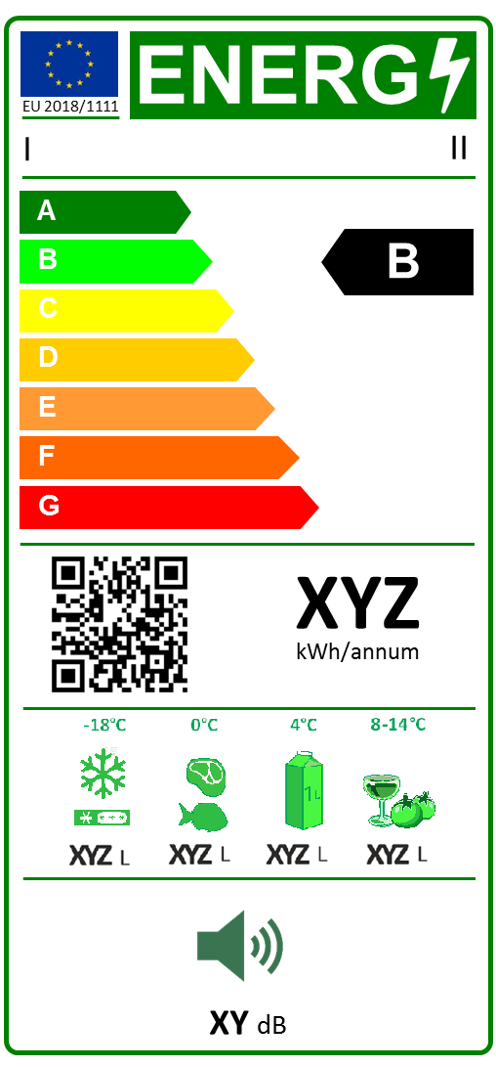
  - For wine storage appliances and low noise refrigerating appliances:
I
II

III

IV
V

VI
VII
VIII
IX

X

The following information shall be included in the label:
I. supplier's name or trade mark;
II. supplier's model identifier;
III. the energy efficiency class determined in accordance with Annex II; the head of the arrow containing the energy efficiency class of the household refrigerating appliance shall be placed at the same height as the head of the arrow of the relevant energy efficiency class;
IV. QR-code linking to model information on the supplier’s website and/or the EU product database;
V. annual energy consumption in kWh per year, AE rounded up to the nearest integer and calculated in accordance with Annex IV. For dedicated freezer appliances the value of AE shall be divided by 0,9 to demonstrate the additional effect of significant quantities of warm load that are typical for these appliances;
VI. if applicable, sum of the volumes of all frozen compartments as indicated in Table 3 of Annex IV, rounded to the nearest integer;
VII. if applicable, sum of the volumes of all chill compartments as indicated in Table 3 of Annex IV, rounded to the nearest integer;
VIII. if applicable, sum of the volumes of all fresh food compartments as indicated in Table 3 of Annex IV, rounded to the nearest integer;
IX. if applicable, sum of the volumes of all unfrozen compartments except fresh food, i.e. cellar, wine storage, pantry types as indicated in Table 3 of Annex IV, rounded to the nearest integer;
X. airborne acoustic noise emissions expressed in dB(A) re1 pW, rounded to the nearest integer.
    - The design of the label shall be in accordance with point 2(1) of this Annex. By way of derogation, where a model has been awarded an 'EU Ecolabel' under Regulation (EC) No 66/2010 of the European Parliament and of the Council (1), a copy of the EU Ecolabel may be added.

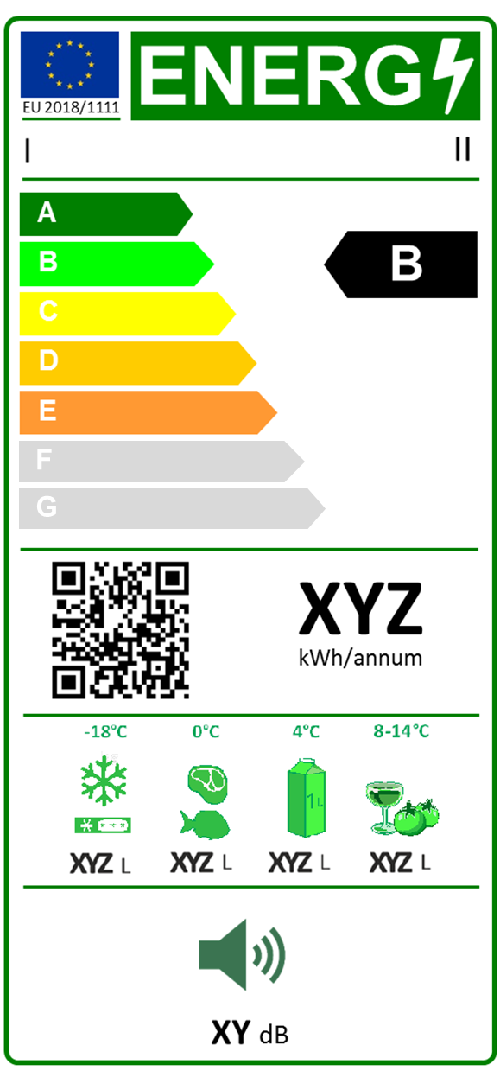
- Label 2
For household refrigerating appliances, except for wine storage appliances:
I
II

III

IV
V

VI
VII
VIII
IX

X

The following information shall be included in the label:
I. supplier's name or trade mark;
II. supplier's model identifier;
III. the energy efficiency class determined in accordance with Annex II; the head of the arrow containing the energy efficiency class of the household refrigerating appliance shall be placed at the same height as the head of the arrow of the relevant energy efficiency class;
IV. QR-code linking to model information on the supplier’s website and/or the EU product database;
V. annual energy consumption in kWh per year, AE rounded up to the nearest integer and calculated in accordance with Annex IV. For dedicated freezer appliances the value of AE shall be divided by 0,9 to demonstrate the additional effect of significant quantities of warm load that are typical for these appliances;
VI. if applicable, sum of the volumes of all frozen compartments as indicated in Table 3 of Annex IV, rounded to the nearest integer;
VII. if applicable, sum of the volumes of all chill compartments as indicated in Table 3 of Annex IV, rounded to the nearest integer;
VIII. if applicable, sum of the volumes of all fresh food compartments as indicated in Table 3 of Annex IV, rounded to the nearest integer;
IX. if applicable, sum of the volumes of all unfrozen compartments except fresh food, i.e. cellar, wine storage, pantry types as indicated in Table 3 of Annex IV, rounded to the nearest integer;
X. airborne acoustic noise emissions expressed in dB(A) re1 pW, rounded to the nearest integer.
    - The design of the label shall be in accordance with point 2(1) of this Annex. By way of derogation, where a model has been awarded an 'EU Ecolabel' under Regulation (EC) No 66/2010 of the European Parliament and of the Council (1), a copy of the EU Ecolabel may be added.

- Label design
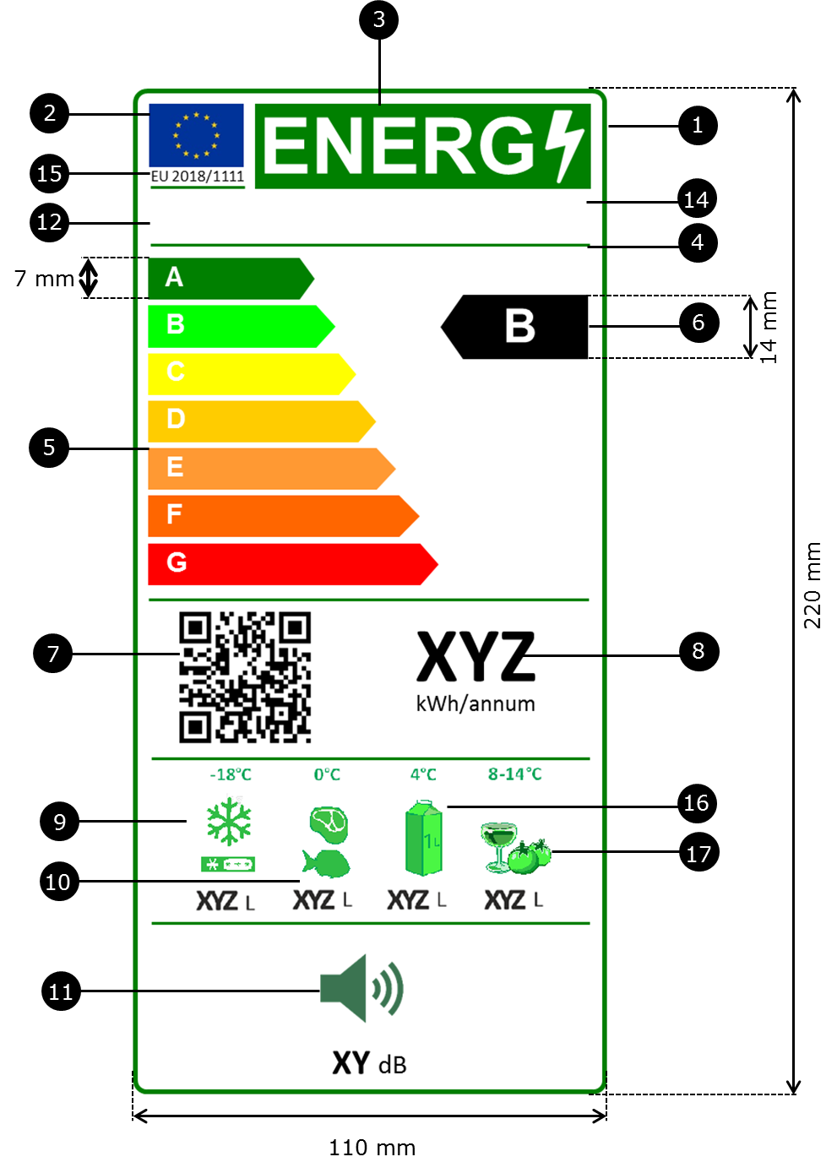
    - For household refrigerating appliances and low noise refrigerating appliances the design of the label shall be as the following:

Whereby:
          - The label shall be at least 110 mm wide and 220 mm high. Where the label is printed in a larger format, its content shall nevertheless remain proportionate to the specifications above.
          - The background of the label shall be white.
          - Colours shall be CMYK - cyan, magenta, yellow and black, following this example: 00-70-X-00: 0 % cyan, 70 % magenta, 100 % yellow, 0 % black.
          - The label shall fulfil all of the following requirements (numbers refer to the figure above):
EU label border stroke: 5 pt - colour: Green 100 % - round corners: 3,5 mm.
EU logo - colours: X-80-00-00 and 00-00-X-00.
Energy label: colour: X-00-00-00.
Pictogram as depicted: EU logo + energy label: width: 92 mm, height: 17 mm.
Sub-logos border: 1 pt - colour: Cyan 100 % - length: 92,5 mm.
A-G scale
- Arrow: height: 7 mm, gap: 0,75 mm - colours:
Highest class: X-00-X-00,
Second class: 70-00-X-00,
Third class: 30-00-X-00,
Fourth class: 00-00-X-00,
Fifth class: 00-30-X-00,
Sixth class: 00-70-X-00 or grey where applicable,
Last class: 00-X-X-00 or grey where applicable.
- Text: Calibri bold 19 pt, capitals and white; '+' symbols: Calibri bold 13 pt, capitals, white, aligned on a single row.
Energy efficiency class
- Arrow: width: 26 mm, height: 14 mm, 100 % black;
- Text: Calibri bold 29 pt, capitals and white; '+' symbols: Calibri bold 18 pt, capitals, white and aligned on a single row.
QR-code: in frame of 20 x 20 mm, either above or below black arrow depending on space available after rating.
Annual energy consumption:
- Border: 3 pt - colour: Cyan 100 % - round corners: 3,5 mm.
- Value: Calibri bold 45 pt, 100 % black.
- Second line: Calibri regular 17 pt, 100 % black.
If applicable, sum of the volumes of all frozen compartments:
- Border: 3 pt - colour: Green 100 % - round corners: 3,5 mm.
- Value: Calibri bold 25 pt, 100 % black. Calibri regular 17 pt, 100 % black.
If not applicable, blank space
Airborne acoustic noise emissions:
- Border: 3 pt - colour: Green 100 % - round corners: 3,5 mm.
- Value: Calibri bold 25 pt, 100 % black.
Calibri regular 17 pt, 100 % black.
If applicable, sum of the volumes of all chill compartments:
- Border: 3 pt - colour: Green 100 % - round corners: 3,5 mm.
- Value: Calibri bold 25 pt, 100 % black.
Calibri regular 17 pt, 100 % black.
If not applicable, blank space
Supplier's name or trademark
Supplier's model identifier
The supplier's name or trademark and model identifier should fit in a space of 90 x 15 mm.
Numbering of the Regulation: Text: Calibri bold 11 pt.
If applicable, sum of the volumes of all fresh food compartments:
- Border: 3 pt - colour: Green 100 % - round corners: 3,5 mm.
- Value: Calibri bold 25 pt, 100 % black. Calibri regular 17 pt, 100 % black.
If not applicable, blank space
If applicable, sum of the volumes of all unfrozen compartments except fresh food, i.e. cellar, wine storage, pantry types:
- Border: 3 pt - colour: Green 100 % - round corners: 3,5 mm.
- Value: Calibri bold 25 pt, 100 % black. Calibri regular 17 pt, 100 % black.
If not applicable, blank space

ANNEX IV
Measurements and calculations
A. Measurements
For the purposes of compliance and verification of compliance with the requirements of this Regulation, measurements and calculations shall be made using harmonised standards the reference numbers of which have been published for this purpose in the Official Journal of the European Union, or other reliable, accurate and reproducible methods, which takes into account the generally recognised state-of-the-art methods. They shall fulfil the conditions and technical parameters set out in points 1 to 6 and in B. points 1 to 2.
- General conditions for testing:
- for refrigerating appliances with anti-condensation heaters that can be switched on and off by the end-user, the anti-condensation heaters shall be switched on and - if adjustable - set at maximum heating;
- for refrigerating appliances with automatically controlled electric anti-condensation heaters, the automatically controlled electric anti-condensation heaters will be switched off or otherwise disabled, where possible, during the measurement of electricity consumption. The electricity consumption of these heaters will be calculated from their power consumption declared by the manufacturer for 10 humidity conditions and 3 ambient temperature conditions.
- for refrigerating appliances with through-the-door devices that can be switched on and off by the end-user, the through-the-door devices shall be switched on during the energy consumption measurement but not operating;
- for the measurement of energy consumption, variable temperature compartments shall operate as the compartment type which has the highest energy consumption;
- for refrigerating appliances that can be digitally connected, this functionality shall not be disabled but there will be no active sending or receiving of data.
- Assessment of volume:
    - General:
The volume shall take into account the exact shapes of the walls including all depressions or projections.
When the volume is determined, internal fittings such as shelves, removable partitions, containers and interior light housings shall be considered as not being in place.
The volume of control housings, evaporator space, air ducts required for proper cooling and operation of the unit, the volume of any fixed or removable partition between compartments and sub-compartments, the space occupied by shelves moulded into the inner door panel shall be considered as being in place and their volumes deducted.
For through the door ice and water dispensers, the ice chute shall be included in the volume up to the dispensing function. The through the door ice and water dispensers and the insulating hump are not included in the volume. No part of the dispenser unit shall be included as volume.
    - Volume of evaporator space:
The volume of the evaporator space shall be the product of the depth, width and height. The total volume to be deducted shall comprise the following:
          - in the case of a forced air evaporator, the total volume of the evaporator cover and behind the evaporator cover shall be deducted, including the volume occupied by the evaporator fan and the fan scroll;
          - in the case of plate style (e.g. roll-bond) evaporators, the volume behind vertically installed plate-style evaporators and the volume above horizontally installed plate -style evaporators if the distance between the horizontal plate -style evaporator and the nearest liner surface above is less than 50 mm. Removable drip trays/troughs shall be considered as not being present;
          - in the case of refrigerant filled shelving, the volume above the uppermost shelf and below the lowermost shelf, if the distance between the shelf and the nearest horizontal plane of the cabinet inner wall is less than or equal to 50 mm. All refrigerated shelves are considered as not present;
          - in case there is a fan installed in an unfrozen compartment with a refrigerated wall evaporator or a plate style evaporator, the volume of the fan.
    - Two-star sections and/or compartments:
Two-star sections and/or compartments are permitted both in the door and in the remaining volume of a refrigerating appliance when all the following conditions are met:
          - the two-star section or compartment is marked with the appropriate identification symbol;
          - the two-star section and/or compartment is separated from the three-star of four-star volume by a partition, container, or similar construction;
          - the rated total two-star section volume does not exceed 20 % of the total volume of the compartment;
          - the instructions give clear guidance regarding the two-star section and/or compartment;
          - the volume of the two-star section and/or compartment is stated separately and is not included in the three-star or four-star volume.
- Storage conditions and target temperatures per compartment type:
The following Table gives the storage conditions and target temperature per compartment type:
Table 3
Storage conditions and target temperature per compartment type
Group | Compartment type | Note | Storage conditions |  | T_{c}  note [1]
 |  |  | Tmin | Tmax
Name | Name | nr. | °C | °C | °C
Un-frozen | Pantry | [2] | +14 | +20 | +17
 | Wine storage | [2][3] | +5 | +20 | +12
 | Cellar | [2] | +2 | +14 | +12
 | Fresh food | [2] | 0 | +8 | +4
Chill | Chill | [4] | −3 | +3 | +2
Frozen | 0-star & ice-making | [5] | n.a. | 0 | 0
 | 1-star | [5] | n.a. | −6 | −6
 | 2-star | [5][6] | n.a. | −12 | −12
 | Freezer (3 and 4-star) | [5][6] | n.a. | −18 | −18
Notes:
^{[1]} T_{c} relates to the target temperature for testing energy consumption and is the average over time and over a set of sensors.
^{[2]} T_{min} and T_{max} relate to average values measured over the test period (average over time and over a set of sensors) .
^{[3]} The average temperature variation over the test period for each sensor shall be no more than ±0,5 K. During a defrost and recovery period the average of all sensors is not permitted to rise more than 1.5 K above the average value of the compartment.
^{[4]} T_{min} and T_{max} relate to instantaneous values during the test period.
^{[5]} T_{max} relates to average values measured over the test period (average over time and over a set of sensors).
^{[6]} During a defrost and recovery period, the maximum temperature of all sensors is not permitted to rise more than 3.0 K.
n.a.=not applicable
- Energy consumption tests household refrigerating appliances:
    - Introduction
The energy consumption of an appliance is determined from measurements taken when tested with appropriate test conditions in an ambient temperature of 32 °C and an ambient temperature of 16 °C. The value of the energy consumption shall be for a temperature control setting (or equivalent point) where all average compartment air temperatures are at or below the target temperatures specified in Table 1 for each compartment type claimed by the supplier. Values above and below target temperatures may be used to estimate the energy consumption at the target temperature for each relevant compartment by interpolation, as appropriate.
The main components of energy consumption to be determined are:
          - total average steady state power consumption P_{ss}, measured at 16 °C ambient temperature and measured at 32 °C ambient temperature;
          - incremental defrost and recovery energy ΔE_{d-f} (in Wh) for products with one or more auto-defrost systems (each with its own defrost control cycle), the defrost and recovery energy for a representative number of defrost and recovery periods for each system shall be determined;
          - defrost interval t_{d-f} (in h) for products with one or more defrost systems (each with its own defrost control cycle), the defrost interval t_{d-f} (in h) shall be determined for each system under a range of conditions.
Throughout all tests the reference average ambient temperatures of 16 and 32 °C have to be maintained with a bandwidth of ± 0,5 K. On top of that, for steady state power consumption the test results will be corrected for smaller deviations from the reference. Note that for all compartments, the air temperatures of the compartment(s) will be measured and not the temperature inside ballasts. The appliance doors will remain closed and no warm load is introduced in the storage volume(s).
Each of these parameters will be determined through separate (sets of) tests. To improve the efficiency and accuracy of testing, the test period is not fixed, but is determined by whether a ‘steady state’ is reached.
Steady state is defined as a condition that occurs when test results comply with a series of acceptance criteria, laid down in an accurate, reliable and reproducible test method, to ascertain that stable test conditions occur. These acceptance criteria include that spread and slope of the average compartment air temperature and average power consumption between a minimum number of non-overlapping sampling periods or ‘blocks’ are within a specific narrow bandwidth. Furthermore there are rules as regards:
          - the minimum number of blocks;
          - position of the blocks (adjacent or not, distance to defrost and recovery period, depending on the purpose of the test);
          - minimum number of temperature control cycles (‘TCCs’) or minimum length in time per block (‘fixed time slices’ in case no repetitive patterns can be established);
          - repeatability (e.g. that a valid set of blocks of test data is preceded by a minimum number of also compliant set of blocks);
          - the type of compartments to measure in a combi-appliance;
          - how to extend the test data if the first test runs do not comply with the acceptance criteria.
Figure 1 gives an illustration of a typical compartment air temperature and electricity input for a refrigeration appliance:
Figure 1
Illustration of a typical compartment air temperature and electricity input for a refrigeration appliance
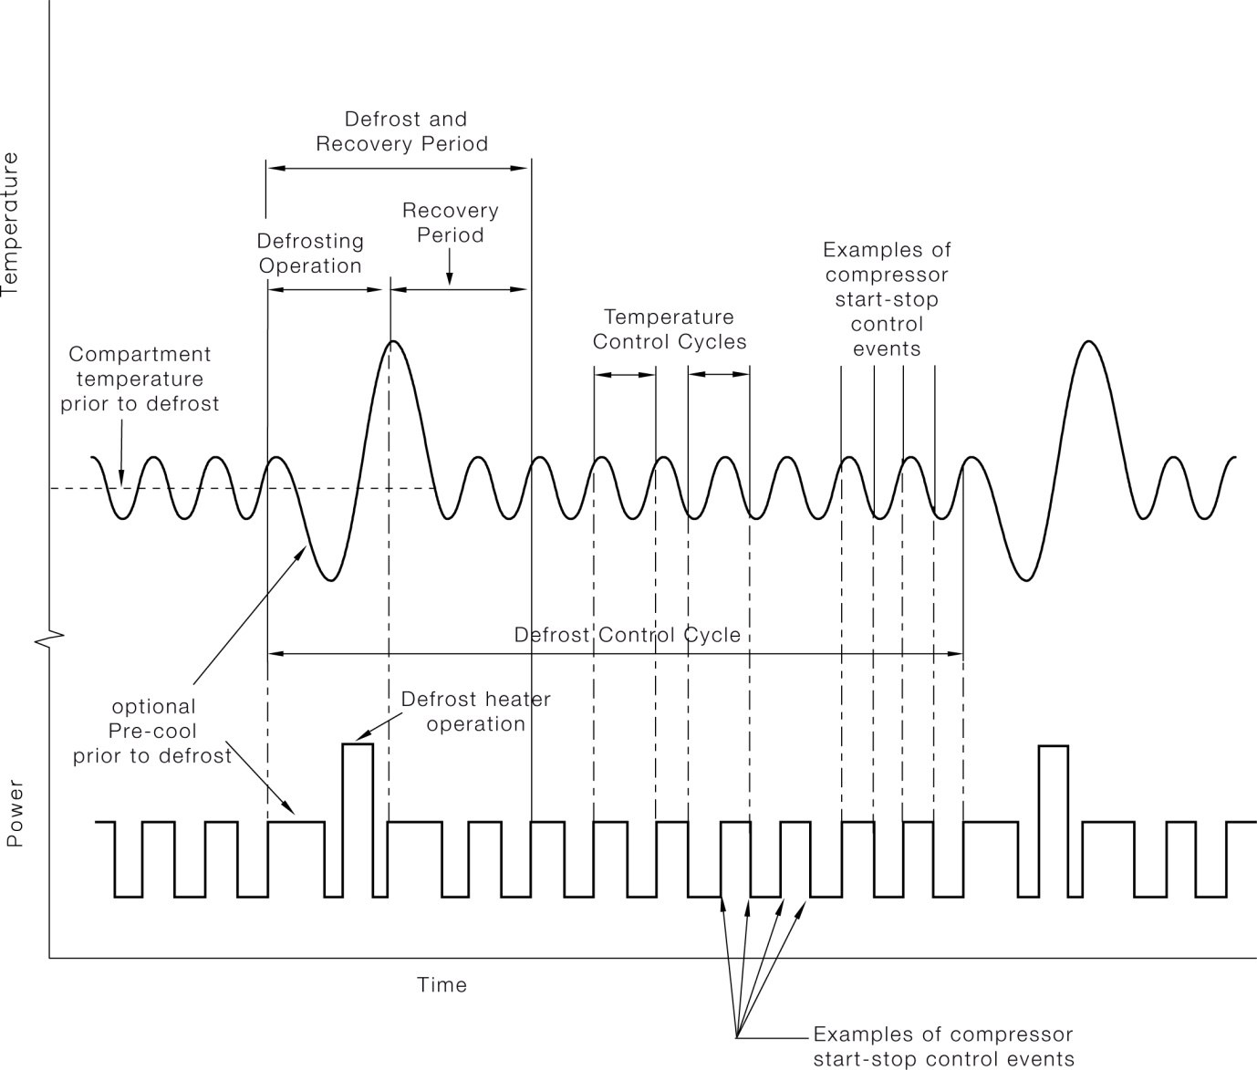
    - Steady state power consumption
        - Manual Defrost
For manual defrost products using a TCC-based test procedure, the acceptance criteria and rules for steady state energy consumption include:
              - a minimum number of 3 adjacent blocks of an equal number of TCCs (at least 1 TCC per block);
              - a minimum test period (6h);
              - a maximum spread across blocks for temperature (0,25K) and power consumption (varies between 1% for a 12h test period and 3% for a test period of 36 hours or more, with linear interpolation in between);
              - a maximum slope between the first and last block for temperature (0,025 K/h) and power consumption (less than 0,25%/h).
A valid steady state test period can start only after already two successive test-periods, each containing three blocks, meet the above criteria. In case of multi-compartment appliances, the temperatures relate to those in the largest frozen and the largest unfrozen compartment or –in case all compartments are either all frozen or all unfrozen—the largest two compartments.
In case of using ‘fixed time slices’ for testing of manual defrost products, the minimum test period is 12h, the maximum power spread is always 1% independent of the test period. The other acceptance criteria are the same as for appliances tested using TCCs.
        - Auto defrost
For auto-defrost appliances also the manual defrost method can be used to establish the steady state energy consumption. Only in case it is difficult to find a valid steady state energy consumption in between defrost and recovery periods two separate blocks may be used, each ending at the start of a defrost and recovery period. Each block shall contain at least 4 TCCs and one block should not be 25% longer or shorter than the other. In case of fixed time slices the blocks shall be no less than 4 h in length and blocks must have equal lengths. If the time between defrost and recovery periods exceeds 48 hours, the start of the second block may be selected after this 48 h period. The maximum allowed average temperature spread between the blocks is 0,5 K. The maximum allowed spreads in power consumption shall be less than 2 % (relative spread) or less than 1 W (absolute spread), whichever is the greater value.
    - Incremental defrost and recovery energy consumption
For auto-defrost appliances the incremental defrost and recovery energy ΔE_{d-f} is established by finding two valid steady state blocks, following steady state acceptance criteria similar to those mentioned in Section 4.(2), one before and one after the defrost and recovery period. The reference point for defrost and recovery period is 2 h after the (first) activation of the defrost heater. The end of the first block is 3 h before and the start of the second block is 3 h after this reference point. Each block contains at least 3 TCCs or has a fixed length of 3 h. The start of the first block shall be no less than 5 h after the initiation of the previous 'defrost heater on' or, in the case where there is no defrost heater, no less than 5 h after the interruption of the refrigeration system related to the automatic defrost. The second block shall not overlap with the subsequent defrost and recovery period.
Note that if these initial start, stop and interval values do not deliver an acceptable result they can be shifted.
The relevant test period runs from the start of the first block until the end of the second block, i.e. with the defrost and recovery period in between. The total energy consumption during this test period is measured. Subsequently, the total energy consumption for that period is calculated as if it were the steady state energy consumption, based on the steady state power measured in the two steady-state blocks. The difference between the two is the incremental defrost and recovery energy consumption.
The test(s) shall be done at least for each temperature control setting. The defrost and recovery period selected for each temperature control setting shall be adjacent to the steady state period used for energy determination. In case there is more extensive test data, the average of at least 4 defrost and recovery incremental energy consumption data, for each control setting, shall be used. In this case at least 50 % of all values of ΔE_{df} shall have the coldest compartment at or below target temperature. A separate value for ΔE_{df} shall be determined for each ambient temperature.
    - Defrost and recovery frequency and interval
There are three methods of defrost interval control, meaning the control parameter that determines the interval between defrost cycles, distinguishing between ‘timer’, ‘compressor run-time’ or ‘variable defrost’, whereby the latter may be based on operational parameters (door-openings, inserting warm load) or direct measurement of frost accumulation.
For the timer-control, which is relatively rare, the interval can be measured directly. Values for at least three defrost intervals shall be determined, with at least one value at an ambient temperature of 16 °C and one value at an ambient temperature of 32 °C.
For the compressor run-time control, the past run-time of the compressor is used as a proxy for the door-openings and inserted warm load.
For the compressor run-time control, the interval can be measured directly. Tests shall be undertaken over a whole defrost control cycle, at least one at each ambient temperature, in order to verify that it is a run time controller and estimate the value of the interval. Complementary test at e.g. other ambient temperatures and/or temperature control settings are required to check consistency of the interval with the compressor run time. The coefficient of variation (standard deviation divided by the mean) of the estimated values for compressor run time shall be less than 10 % for the defrost intervals examined; otherwise the controller shall be qualified as a ‘variable defrost’ controller.
For a variable defrost controller the interval is calculated on the basis of values specified by the manufacturer for Δt_{d−max} maximum possible defrost interval at an ambient temperature of 32 °C and Δt_{d−min} minimum possible defrost interval at an ambient temperature of 32 °C, both expressed in hours.
The value for Δtdf16 at an ambient temperature of 16 °C shall be double the value of the defrost interval Δtdf32 for an ambient temperature of 32 °C.
Δt_{d−min} shall not exceed 12 h at an ambient temperature of 32 °C (elapsed time). Δt_{d−max} shall not exceed 96 h at an ambient temperature of 32 °C.
Δt_{d −min} shall be based on the shortest conceivable defrost interval under heavy usage conditions (i.e. heavy use, frequent door openings and high humidity) at an ambient temperature of 32 °C. Tests under heavy usage conditions to verify the claimed value may be undertaken. The value for Δt_{d−max} shall be achievable under test conditions with compartment temperatures at or below target temperatures in steady state. Manufacturers shall specify any special condition required to achieve the claimed value.
In case the manufacturer does not supply declared values for Δt_{d−min} and Δt_{d−max}, default values of 6 h for Δt_{d−min} and 96 h for Δt_{d−max} shall be used, resulting in a Δt_{df32} of 24 h and a Δtdf16 of 48 h.
If, apart from the manufacturer not declaring the values, the verification test shows the operation not consistent with a variable defrost controller then the averages of 3 defrost intervals at both 16 and 32°C ambient is measured and used as values for Δt_{df16} and Δt_{df32} respectively, whereby Δt_{df16} shall not exceed 20 h and Δt_{df32} shall not exceed 10 h.
- Energy consumption tests low-noise refrigerating appliances:
Energy consumption of low-noise appliances shall be tested only at an ambient temperature of 25 °C. Low-noise appliances have no auto-defrost and thus the tests only determine the steady state power consumption P_{ss25}. Otherwise, the test procedure is identical to that of dedicated cellar or pantry household appliances.
- Performance of chill compartments:
In order to avoid loopholes in the declaration of chill compartments, as defined in Table 3, the following additional requirements apply:
  - for a variable temperature compartment rated as fresh food and/or chill, the energy efficiency index shall be determined for each temperature condition and the highest value shall be applied;
  - a chill compartment shall be able to control its average temperature during energy testing within a certain range without user-adjustments of its control; this shall be verified as follows:
      - determine the reference chill compartment temperature T_{ccma,ref} by performing an energy consumption test at 32°C ambient. T_{ccma,ref} is the interpolated value of T ccma (e.g. found at the interpolated fresh food compartment Tma =4°C),
      - perform an energy consumption test at 16°C. T_{ccma} shall be within T_{ccma,ref±1,5K} for any setting used for interpolation, with the limitation that the fresh food compartment T_{ma} shall be in the range from 2 to 6°C.
B. Calculations
- For household refrigerating appliances
    - Energy Efficiency Index EEI:
The Energy Efficiency Index EEI compares the Annual Energy consumption AE (in kWh/a) with the reference Standard Annual Energy consumption SAE (in kWh/a) and is calculated as:
$EEI= AE/ SAE$;
the outcome is a dimensionless number, usually expressed as a percentage (%).
    - Annual Energy consumption AE:
The Annual Energy consumption AE of a household refrigerating appliance is based on the measurements according Section A at two ambient test temperatures, 16 and 32°C, regarding:
          - steady state power consumption P_{ss} (per ambient temperature P_{ss16}, P_{ss32}) in W;
          - the incremental defrost energy consumption ΔE_{d-f} (per ambient temperature ΔE_{d-f16} and ΔE_{d-f32}) in Wh;
          - defrost and recovery interval td-f in h (per ambient temperature t_{d-f16} and t_{d-f32}).
The average daily energy consumption E_{daily} in kWh/24h is calculated from values at both ambient test temperatures E_{16C} and E_{32C} as follows:
E_{daily} = (E_{16C} + E_{32C});
with E_{16C} = 0.001 ∙ 24 ∙ (P_{ss16} + ΔE_{d-f16} / t_{d-f16}) and;
E_{32C} = 0.001 ∙ 24 ∙ (P_{ss32} + ΔE_{d-f32} / t_{d-f32}).
The values for E_{16C} and E_{32C} may result from two or three point interpolations of outcomes from several test-runs.
The Annual Energy consumption AE in kWh/a is as follows:
AE = 365∙( E_{16C} + E_{32C})∙0,5.
    - Standard Annual Energy consumption SAE:
The Standard Annual Energy consumption SAE of a household refrigerating appliance is based on the type(s) and volume(s) of the compartments V_{c} (in dm³ or litres, with one decimal), its total volume V (in dm³ or litres, rounded to the nearest integer) and a series of parameters given in Table 4.
The Standard Annual Energy consumption SAE, in kWh/a, is calculated as follows:
$SAE=C∙D∙L∙\sum_{c=1}^{n}{ A_{c}∙B_{c} ∙\frac{ V_{c}}{V} ∙\left(N_{c}+ V∙r_{c}∙M_{c}\right)}$;
where c is the compartment index suffix and n is the total number of compartment types.
Note that for the variable temperature compartments the compartment type with the lowest target temperature is chosen for which it is declared suitable.
Table 4
Default values of parameters per compartment type in the calculation of EEI
Compartment type | r_{c} | N_{c} | M_{c} | A_{c} | B_{c} | C | D | L_{c}
Name | - | - | - | - | - | - | - | -
Pantry | 0.35 | 75 | 0,12 | 1,00 | 1,04 | between 1,15 and 1,56 for  refrigerator-freezersª,  1,15 for other combis,  1,00 for dedicated appliances | 1.02, 1.035, 1.05 for 3,4 or more than 4 doors | 1,00
Wine storage | 0.6
Cellar | 0.6
Fresh food | 1.00
Chill | 1.1 | 138 | 0,12 |  | 1,06
0-star & ice-making | 1.2 | 138 | 0,15 | 1,10 | 1,10
1-star | 1.5
2-star | 1.8
Freezer (3 and 4-star) | 2.1 |  |  |  |  |  |  | 0,9  if dedicated
ª C for refrigerator-freezers is determined as follows:
where frzf is the freezer volume V_{freezer} as a fraction of total volume with frzf=V_{freezer}/V:
- if frzf≤0,3 then C=1,3+0,87∙frzf;
- else if 0,3<frzf<0,7 then C=1,89−1,1∙frzf;
- else C=1,15.

- Calculation methods for low-noise refrigerating appliances
The Energy Efficiency Index EEI (expressed in %) is calculated as above, i.e.:
EEI=AE/AEC.
Basis for the assessment of the energy consumption of low noise refrigerating appliances is the steady state power consumption at a single ambient temperature of 25 °C P_{ss25} (in W), measured in accordance with Section A.5.
The daily energy consumption E_{daily25} at 25°C ambient temperature (in kWh/24h) is given by:
E_{daily25} = 0,001 ∙ 24 ∙ P_{ss25}.
The annual energy consumption AE (in kWh/a) is given by:
AE = 365 ∙ E_{daily2}.
Low noise appliances are manual defrost (A_{c}=1), stand-alone (B_{c}=1), dedicated (C=1), single door (D=1) appliances with cellar (r_{c}=0,6 ) or pantry (r_{c}=0,35 ) compartment type as defined in Tables 3 and Table 4. The latter implies N_{c}=75 and M_{c}=0,12 and L=1. The Standard Annual Energy consumption SAE (in kWh/a) can thus be simplified as follows:
- for cellar types: SAE= 75 + V ∙ 0,6 ∙ 0,12 = 75 + 0,072V;
- for pantry types: SAE= 75 + V ∙ 0,35∙ 0,12 = 75 + 0,042V.

ANNEX V
Product information sheet
- The information in the product information sheet of household refrigerating appliances and low noise refrigerating appliances shall in the product brochure or other literature provided with the product:
      - supplier's name or trade mark;
      - supplier's model identifier;
      - energy efficiency class of the model in accordance with Annex II;
      - where the model has been awarded an 'EU Ecolabel award' under Regulation (EC) No 66/2010, this information may be included;
      - annual energy consumption in kWh per year, is parameter AE rounded up to the nearest integer and calculated in accordance Annex IV, whereby for dedicated freezers the calculated AE value is divided by 0,9 to find the annual energy consumption and described as 'Energy consumption "XYZ" kWh per year, based on standard test results in steady state conditions;
      - volume, type and, if applicable, star rating of each compartment in accordance with Annex IV, if any, Variable temperature compartment will be identified separately with the compartment type characteristics for which it is declared to be suitable;
      - the mention ‘auto-defrost' for the relevant compartment(s);
      - 'power cut safe "X" h' defined as 'temperature rise time';
      - 'freezing capacity' in kg/24 h;
      - 'climate class' in accordance with the definition in Annex I, and expressed as: 'Climate class: W [climate class acronym]. This appliance is intended to be used at an ambient temperature between "X" [lowest ambient temperature] °C and "Y" [highest ambient temperature] °C';
      - ‘low noise appliance’ or ‘dedicated wine storage appliance’ , if applicable;
      - 'airborne acoustic noise' emissions expressed in dB(A) re1 pW, rounded to the nearest integer;
      - if the model is intended to be a built-in appliance, an indication to this effect;
      - for wine storage appliances, the following information: 'This appliance is intended to be used exclusively for the storage of wine'. This point shall not apply to household refrigerating appliances that are not specifically designed for wine storage but may nevertheless be used for this purpose, nor to household refrigerating appliances that have a wine storage compartment combined with any other compartment type.
- One product information sheet may cover a number of refrigerating appliances models supplied by the same supplier.
- The information contained in the product information sheet may be given in the form of a copy of the label, either in colour or in black and white. Where this is the case, the information listed in point 1 not already displayed on the label shall also be provided.

ANNEX VI
Technical documentation
The technical information referred to in Article 3(c) shall include the technical parameters for measurements, established in accordance with Annexes IV:
  - the name and address of the supplier;
  - a general description of the household refrigerating or low noise refrigerating model, sufficient for it to be unequivocally and easily identified;
  - where appropriate, the references of the harmonised standards applied;
  - where appropriate, the other technical standards and specifications used;
  - identification and signature of the person empowered to bind the supplier;
  - technical parameters for measurements as follows:
      - overall dimensions, expressed to the nearest millimetre, means space taken up by the refrigerating appliance (height, width and depth) with doors or lids closed;
      - total volume of the appliance, in dm³ or litres rounded to the nearest integer, matching the sum of the compartment volumes in point c) hereafter;
      - volume, in dm³ or litres rounded to one decimal place, per compartment, identified by the name and meeting the performance requirements of the compartment type as indicated in Table 1. Variable temperature compartment will be identified separately with the compartment type characteristics for which it is declared to be suitable;
      - target temperature, in °C rounded to the nearest integer, per compartment;
      - ‘low noise appliance’ or ‘wine storage appliance’ , if applicable;
      - climate class: SN, N, ST or T;
      - minimum and maximum ambient temperature, in °C rounded to the nearest integer, for which the appliance is suitable;
      - daily energy consumption, E_{daily} in kWh/24h rounded to three decimal places;
      - annual energy consumption, AE in kWh rounded to the nearest integer;
      - standard annual energy consumption, SAE in kWh rounded to the nearest integer;
      - total average steady state power consumption, P_{ss} in W rounded to the nearest integer;
      - energy efficiency index EEI, number expressed in % rounded to the nearest integer;
      - defrosting type, means the method to remove frost accumulation on the evaporator(s) of an appliance, distinguishing ‘auto-defrost’ or ‘manual defrost’;
      - defrost interval control, meaning the control parameter that determines the interval between defrost cycles, distinguishing between ‘timer’, ‘compressor run-time’ or ‘variable defrost’, whereby the latter may be based on operational parameters (door-openings, inserting warm load) or direct measurement of frost accumulation;
      - incremental defrost and recovery energy consumption, ΔE_{d-f} in Wh rounded to the nearest integer;
      - defrost interval, t_{d-f} in h, rounded to two decimal places;
      - temperature rise time, in h rounded to hours and whole minutes;
      - specific freezing capacity, x in kg/12h, rounded to two decimal places;
      - winter switch present, yes/no;
      - star rating in case of a freezer compartment with this feature as defined in Annex I;
      - fast freeze in case of a freezer compartment with this feature as defined in Annex I;
      - anti-condensation heater type ‘manual on-off’, ‘ambient controlled’, ‘other’ or ‘none’;
      - airborne acoustical noise emissions expressed in dB(A) re1 pW, rounded to the nearest integer;
      - Individual measurement results for P_{ss} , ΔE_{d-f} t_{d-f} from valid test runs at 16 °C and 32 °C ambient temperature for household appliances and at 25 °C ambient temperature for low noise appliances;
      - If applicable, interpolation or triangulation calculations to arrive at the assessment of E_{daily} per relevant ambient temperature.

ANNEX VII
Information to be provided in the case of distance selling, except distance selling on the Internet
1. Any paper based distance selling must show the energy class and the range of available efficiency classes as following the example below, with the colour of the arrow matching the letter of the energy class:

It must be possible for the customer to access the full label and the product information sheet through a free access website, or to request a printed copy.
2. Telemarketing based distance selling must specifically inform the customer of the energy class of the product and the range of the energy classes available on the label, and that they can access the full label and the product information sheet through a free access website, or by requesting a printed copy.
Annex VIII
Information to be provided in the case of sale, hire or hire-purchase through the internet
- The appropriate label made available by suppliers in accordance with Article 3.1(g) shall be shown on the display mechanism in proximity to the price of the product. The size shall be such that the label is clearly visible and legible and shall be proportionate to the size specified in point 2 of Annex III for household refrigerating appliances and low noise refrigerating appliances. The label may be displayed using a nested display, in which case the image used for accessing the label shall comply with the specifications laid down in point 3 of this Annex. If nested display is applied, the label shall appear on the first mouse click, mouse roll-over or tactile screen expansion on the image.
- The image used for accessing the label in the case of nested display shall:
      - be an arrow in the colour corresponding to the energy efficiency class of the product on the label;
      - indicate on the arrow the energy efficiency class of the product in white in a font size equivalent to that of the price; and
      - have one of the following two formats:
- In the case of nested display, the sequence of display of the label shall be as follows:
      - the image referred to in point 2 of this Annex shall be shown on the display mechanism in proximity to the price of the product;
      - the image shall link to the label;
      - the label shall be displayed after a mouse click, mouse roll-over or tactile screen expansion on the image;
      - the label shall be displayed by pop up, new tab, new page or inset screen display;
      - for magnification of the label on tactile screens, the device conventions for tactile magnification shall apply;
      - the label shall cease to be displayed by means of a close option or other standard closing mechanism;
      - the alternative text for the graphic, to be displayed on failure to display the label, shall be the energy efficiency class of the product in a font size equivalent to that of the price.
The appropriate product information sheet made available by suppliers in accordance with Article 3(g) shall be shown on the display mechanism in proximity to the price of the product. The size shall be such that the product information sheet is clearly visible and legible. The product information sheet may be displayed using a nested display, in which case the link used for accessing the fiche shall clearly and legibly indicate “Product information sheet”. If nested display is used, the product information sheet shall appear on the first mouse click, mouse roll-over or tactile screen expansion on the link.

ANNEX IX
Verification procedure for market surveillance purposes
The verification tolerances defined in this Annex relate only to the verification of the measured parameters by Member State authorities and shall not be used by the supplier as an allowed tolerance to establish the values in the technical documentation. The values and classes on the label or in the product fiche shall not be more favourable for the supplier than the values reported in the technical documentation.
When verifying the compliance of a product model with the requirements laid down in this Delegated Regulation, for the requirements referred to in this Annex, the authorities of the Member States shall apply the following procedure:
- the Member State authorities shall verify one single unit of the model;
- the model shall be considered to comply with the applicable requirements if:
      - the values given in the technical documentation pursuant to Article 3.3 of Regulation (EU) 2017/1369, and, where applicable, the values used to calculate these values, are not more favourable for the supplier than the corresponding values given in the test reports.
      - the declared values meet any requirements laid down in this Regulation, and any required product information published by the supplier does not contain values that are more favourable for the manufacturer or importer than the declared values; and
      - when the Member State authorities test the unit of the model, the determined values (the values of the relevant parameters as measured in testing and the values calculated from these measurements) comply with the respective verification tolerances as given in Table 5;
- if the results referred to in point 2(a) or (b) are not achieved, the model and all models that have been listed as equivalent household refrigerating appliance models in the manufacturer's or importer's technical documentation shall be considered not to comply with this Regulation;
- if the result referred to in point 2(c) is not achieved, the Member State authorities shall select three additional units of the same model for testing. As an alternative, the three additional units selected may be of one or more different models that have been listed as equivalent models in the manufacturer's or importer's technical documentation;
- the model shall be considered to comply with the applicable requirements if, for these three units, the arithmetical mean of the determined values complies with the respective verification tolerances given in Table 5;
- if the result referred to in point 5 is not achieved, the model and all models that have been listed as equivalent household refrigerating appliance models in the manufacturer's or importer's technical documentation shall be considered not to comply with this Regulation;
- the Member State authorities shall provide all relevant information to the authorities of the other Member States and to the Commission without delay after a decision being taken on the non-compliance of the model according to points 3 and 6;
The Member State authorities shall use the measurement and calculation methods set out in Annexes IV.
The Member State authorities shall only apply the verification tolerances that are set out in Table 5 and shall only use the procedure described in points 1to 7 for the requirements referred to in this Annex. No other tolerances, such as those set out in harmonised standards or in any other measurement method, shall be applied for parameters in Table 5.
Table 5
Verification tolerances for measured parameters
Parameters | Verification tolerances
Volume | The determined value shall not be less than the declared value by more than 3 % or 1 litre, whichever is the greater value. Where the volumes of the cellar compartment and the fresh food storage compartment are adjustable, relative to one another, by the user, the volume shall be tested when the cellar compartment is adjusted to its minimum volume.
Freezing capacity | The determined value shall not be less than the declared value by more than 10 %.
Energy consumption | The determined value shall not exceed the declared value of the annual energy consumption AE by more than 10 %.

ANNEX X
Displaying the energy class and the range of the efficiency classes in visual advertisements and in promotional material
1. For the purposes of ensuring conformity with the requirements laid down in Article 3(1)(e) and Article 4(1)(c), the energy class and the range of efficiency classes available on the label shall be shown on visual advertisements as follows, with the colour of the arrow matching the letter of the energy class:

2. For the purposes of ensuring conformity with the requirements laid down in Article 3(1)(f) and Article 4(1)(d) the energy class and the range of efficiency classes available on the label shall be shown in promotional material as follows, with the colour of the arrow matching the letter of the energy class:

T _{ccma} = The time averaged chill compartment temperature is the integrated time average of the instantaneous average chill compartment temperature (T_{cca}) or the arithmetic average of the integrated time averaged chill compatment temperatures (T_{ccim}) (both methods give the same result). The suffix ‘cc’ indicates that T_{ma}, T_{im} and T_{a} relate to a chill compartment type.

