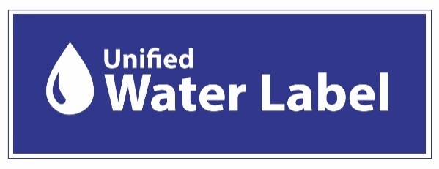
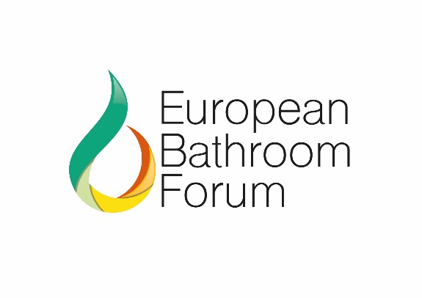

3 YEAR TRANSITION ROAD MAP – ACHIEVING 80% MARKET COVERAGE

The Unified Water Label (UWL) launched during the ISH Fair in Frankfurt is the result of more than 2 years extensive discussions of a technical, marketing and governance structure under the ‘Best of All’ initiative, that brings 4 existing European Labelling schemes for water using bathroom products under one easy to understand Label. Discussions with all stakeholders unanimously agreed on a new design label that embraces water and energy metrics supported by a united technical criterion.

The ‘Best of All Approach’ sees 4 of the existing Labelling Schemes in Europe come together under the Unified Water Label banner. The first stage in the merger is to ensure economic viability and compliance with National regulation for each scheme during a two-year transition period. That commences January 2019.

The transition period will allow registered brands of each scheme to transfer to the agreed technical criteria, also providing the Technical Committee time to address any outstanding areas of change. Merging differing technical criteria from the 4 schemes should not be underestimated at the same time as the Industry collectively seeks a Voluntary Agreement (VA) for the Unified Water Label.

This roadmap identifies area of activity over the next three years that will see the Unified Water Label achieve 80% coverage of units sold in the EU. The Unified Water Label currently represents brands who collectively have a 62% of units sold in the EU.

As part of a VA, manufacturers commit to registering all relevant products that meet the Scheme criteria. The merging of 4 existing schemes will see the Unified Water Label reach 68% of units sold when all products move to Unified Water Label registration.

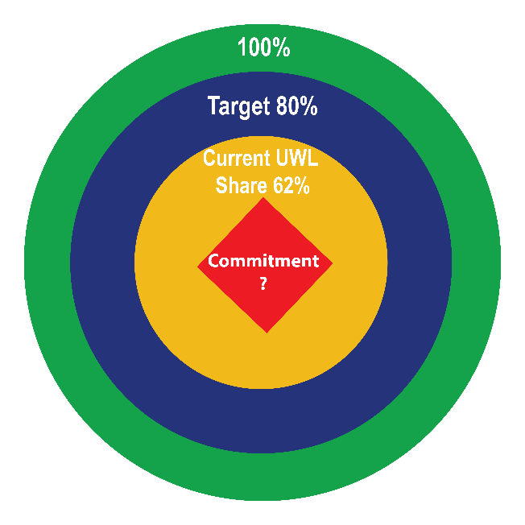
Determining the base data to establishing market share represented is key to ensuring accurate data and progress is monitored. The Unified Water Label has appointed RSM Global as the Independent Inspector and commenced the process to establish the actual market representation of the registered brands, utilising an electronic form for a simple and quick conduit for data collation.

Due to the complexity of distribution across the EU it is vital that the Unified Water Label collaborates with major merchant, distributors and retailers who will encourage own label manufacturers and other brands to engage with the Unified Water Label. Positive steps are being taken in this direction.

KEY MILESTONES FOR 2019

- Launch of Unified Water Label at ISH with The Event
- Seek attendance at The Event from:
- Distributors
- Retailers
- Manufacturers, both supporters and none
- Media
- Other Stakeholders including representatives from EU Commission
- Record visibility of the Label and support for future marketing opportunities
- Widely promote the Unified Water Label at ISH
- Post event issue press release across the EU

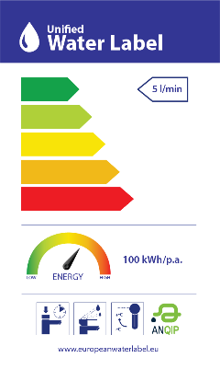
- Commence data collation with committed companies to ascertain the base market share, using the Independent Inspector that will support the VA proposal, completing this collation within a three-month period and before June 2019
- Submit the VA proposal to DG Env with supporting papers by end of July 2019
- Participate within the Eco-Design Consultation forum following submission of proposal
- Undertake any activity following the Consultation
- Constantly refresh website with all relevant documentation, marketing material etc
- Commence the merging of existing databases across the 4 Schemes using the adapted label in the first instance encouraging movement and compliance to the Unified Water Label within a two-year transition period – to commence May 2019
- Identify any outstanding technical criteria issues that require addressing
- Commence formation of a legally accepted not for profit organisation to operate the Scheme, to commence June 2019 onwards
- Appoint Director and support administration
- During December 2019 the Independent Inspector will report progress towards achieving the 80% of units sold
- Seek to harmonise the Unified Water Label with existing Building Regulations such as LEED, BREAM
Indicates these actions have been undertaken

Achieving the 80% market coverage of units sold in the EU

A key aspect of being awarded a VA is verification of market coverage by an Independent Inspector. This data will provide a credible base for the Unified Water Label to grow and achieve the 80% of the market by units as deemed necessary to be awarded a VA.

Those manufacturers who have signed and returned the commitment letter will be requested to submit data to the Independent Inspector to verify market share of registered products and to project timescale to full coverage.

Seeking Commitment from other Stakeholders

The European Bathroom market is driven by globalisation and supported by complex channels to market. A high % of products are imported via a differing tier of distribution channels. The European Bathroom Industry is predominately an RMI (refurbishment, maintenance and improvement) market for existing buildings. Where products for installation are selected via the internet from manufacturers websites or by the installer or builder, as such the distribution channel plays a pivotal role in selecting water and energy efficient products.

The 154 brands currently supporting the Unified Water Label, together with the merger of the 4 Schemes databases will represent 68% of the European Union market for taps and showers, of which 13% is associated to the UK market. The Unified Water Label represents 13 differing categories across water using bathroom products. The road map has only identified those relevant to achieving the Voluntary Agreement. However, all activity will focus on all the product categories associated with the Unified Water Label. The ceramic Industry is currently representative of brands having a collective 70% market share for WC’s and flushing mechanism.

Using BRG Consult report we have identified the top 10 countries for sales volume of taps and showers; Germany, France and UK account for 50% of the units sold, within EU28 with Italy, Poland, Spain, Netherlands, Austria, Belgium and Czech Republic the following 7 countries with the highest sales. The Unified Water Label has identified the key players within these markets with an aim to encourage them to join the Scheme if not already a supporter.

Discussions are ongoing with distributors, retailers and merchants that will provide a conduit for information on the Scheme progress and encouraging further support from own label suppliers.

Using Statista.com the following European countries are the top 10 in water use per capita; Greece, Spain, Turkey, Netherlands, Hungary, France, Belgium, Slovenia, Germany and Italy. Using the Unified Water Label registered companies, strong cohesive consumer messaging on behaviour, associated with raising visibility of the Unified Water Label will be undertaken to encourage a greater informed choice at point of sale.

2020 MILESTONES

As the Scheme progresses towards a Voluntary Agreement awarded, the Independent Inspector will undertake a review on progress twice yearly. June and December in 2020 will see further progress reports undertaken.

A Stakeholder forum will be held mid-year 2020 to discuss progress and any further necessary activity required during the transition stage, aligning the 4 schemes under the ‘Best of All’ approach into the Unified Water Label, thus ensuring economic stability for all. The transition is planned to conclude by March 2021. At this time all companies will have aligned fully to the Unified Water Label criteria.

During 2020 a not for profit organisation will have been fully formed and legally accepted into Belgium law.

Activity will continue to encourage all relevant companies and associated trade bodies to support the Unified Water Label activity in achieving the goal.

Discussions and progress reports will be maintained with representatives of the European Commission.

2021 MILESTONES

2021 will see the transition complete and all registered brands across the 4 Schemes fully embracing the technical criteria and image of the Unified Water Label. It is envisaged that a major launch of the Unified Water Label achieving the VA will be undertaken at ISH 2021, this will be dependent on achieving the VA.

A Stakeholders event will take place during the ISH event.

TARGETS
- March-June 2019
- Identify base % of market share of commitment
- Compare with % of market represented by registered brands
- Align the two
- Target major brands not yet committed to the Unified Water Label
- Encourage further integration with existing Schemes

- December 2019
- Ascertain progress achieved
- Moved to 68% of market as all registered brands currently supporting the 4 schemes have fully committed to the Label
- Link the Unified Water Label to existing Building legislation and/or best practice, providing opportunities

- June 2020
- Ascertain progress with Stakeholder Forum event
- 73% of market now committed to the Scheme and registered product
- Independent Inspector verifies market penetration and visibility

- December 2020
- Issue progress report
- 78% of market now committed and registered onto the Scheme
- Independent Inspector verifies market penetration and visibility

- March 2021
- Scheme launch VA if awarded at ISH 2021
- 83% of market now committed and registered onto the Unified Water Label with visibility of the label in the market place, websites and product literature

- 2021-2022
- Maintain and grow market share and manufacturers commitment
- Analyse the market and Scheme to ensure that the environmental targets are in line, amend accordingly via the Steering Committee
- Continue to review the Unified Water Label Scheme

BRG Global Report taps and showers 2016 (publicly available for purchase)
https://ec.europa.eu/energy/en/voluntary-agreements-under-eco-design-legislation
https://eur-lex.europa.eu/legal-content/EN/TXT/?uri=uriserv:OJ.L_.2016.329.01.0109.01.ENG&toc=OJ:L:2016:329:TOC
http://www.Statista.com

