DRAFT Guidelines accompanying

Commission Regulations (EU) No 2019/2021 & (EU) 2019/2013 Laying down Ecodesign and Energy Labelling Requirements for Electronic Displays
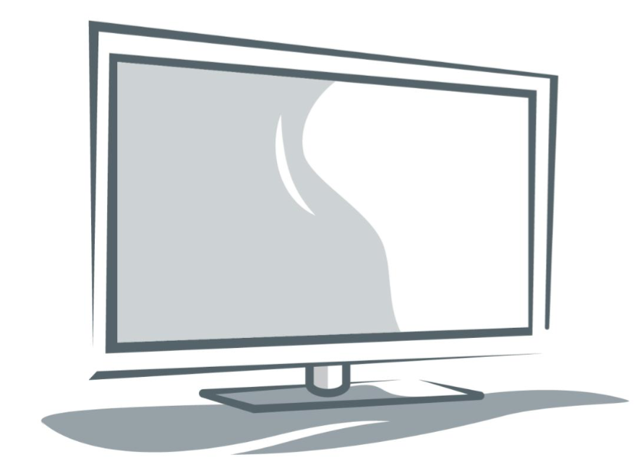

Table of Contents
Introduction 1
Purpose of the guidelines and disclaimer 1
Regulation 2019/2021 1
SCOPE 1
Integrated displays 2
Industrial displays 2
Control panels 2
Displays integrated or to be integrated into medical equipment 3
LED tiles 3
Energy efficiency index calculation curve 3
Colour Gamut 3
TV modes providing audio function only 3
Technical documentation 3
Automatic brightness control (ABC) 4
Mandatory user warnings, when modifying configuration parameter values 4
Automatic powerdown in displays powering other devices 6
Network standby activation 6
Network standby implementation 7
Peak white luminance and luminance ratio 7
Cadmium logo 8
Flame retardants 8
Repair and spare parts 9
Availability of capacitors, batteries and connectors as spare parts 9
Repair information availability 9
Spare part availability verification process 9
Removability of batteries and accumulators 10
Commonly available tools 10
Design for outdoor use 10
Software and firmware-related requirements 10
Technical documentation for Ecodesign 11
Verification procedure 11
Regulation 2019/2021 12
Provision of the new energy label and display 12
Indication of Energy Class and Range of classes available on the label 12
Correction factor for signage displays 13
Off mode declaration in product fiche and technical documentation 13
ABC-related parameters in the technical document 13

Introduction
The Ecodesign and Energy Labelling Regulations for electronic displays were both published in the official Journal on 5 December 2019.
Throughout this document the wording “display” is used to refer to the products in scope of the two regulations.
The ecodesign Regulation repeals Regulation (EC) 642/2009 on ecodesign requirements for televisions. The new ecodesign requirements apply from 1 March 2021.
The Energy Labelling Regulation repeal Regulation (EU) 1062/2010 on energy labelling of televisions. The new energy labelling requirements also apply from 1 March 2021
Both regulations updates their respective requirements and adapt the to the technology evolution since the previous decade.

Purpose of the guidelines and disclaimer
These guidelines are intended to be used only for facilitating the implementation of the Regulation. They are not intended to replace the Regulations or to provide “interpretation” beyond their intent. These guidelines only reflect the opinion of the Commission services and are not legally binding: it is the text of the Regulation which is legally binding and which is directly applicable in the EU Member States
A finally binding legal interpretation of EU legislation may only be provided by the European Court of Justice. The guidelines are without prejudice to the position the Commission might take should an issue arise in a procedure before the European Court of Justice.
Requirements originating from these Regulations have to be met in addition to further relevant legal requirements, e.g. originating from Directive 2006/95/EC on the harmonization of the laws of Member States relating to electrical equipment designed for use within certain voltage. As an example, the marking of maximum rated power consumption cannot be replaced by marking the television with the average energy consumption.
The following topics, covered in the guidelines, should help respond to possible questions arising, mostly by manufacturers.

Regulation 2019/2021

SCOPE
Scope enlargement, from televisions and television monitors to a number of additional electronic displays, Is a first relevant update introduced by the reviews of the regulations and responds to a product convergence trend and to the coming to market of new product categories, very relevant from the energy use perspective. Moreover, new material efficiency requirements are introduced, thus covering also embodied energy aspects, reducing premature end of life with repair requirements and by facilitating recovery of materials at end of life.
The products scope list subdivides displays into 3 groups. Products in the first group are completely excluded from the Regulation. Products in the second group are excluded from requirements in points A and B of Annex II, i.e. from the ”on mode” energy efficiency requirements, but standby material efficiency requirements still apply. The third group is excluded from any energy-related requirement and only material efficiency and information requirements apply.

Integrated displays
Displays integrated or manufactured specifically to be integrated into products already covered by any other ecodesign Regulation, such as e.g. in all-in-one computers, in domestic refrigerators or washing machines are explicitly out of scope. Requirements on these displays, if any, are or will be part of the regulation covering the product where they are integrated.
For displays integrated in products not covered by any ecodesign measure, the exclusion is upon specific conditions. Point (g) of Article 1.2 refers to displays that are ‘Components and sub-assemblies’, that are defined, in Article 2 as “parts intended to be incorporated into products which are not placed on the market and/or put into service as individual parts for end-users or the environmental performance of which cannot be assessed independently;”
Therefore, integrated displays that are components or sub-assemblies of products, for which the performance cannot be assessed independently of the containing product, are totally excluded from the scope of this regulation. This refers both to:
- energy requirements (Annex II A, B and C), e.g. because the product does not provide a suitable signal interface for injecting the video test loop to assess energy efficiency, or has a power supply system integrated into the hosting product and
- material efficiency requirements (Annex II.D), e.g. because the casing is part of the hosting product, or the display needs to resist to specific environmental constraints, such as external radiofrequency interference, water tightness, heat, vibrations, etc.
Displays integrated into products covered by an Ecodesign measure or a voluntary industry agreement replacing Ecodesign measure, such, e.g. computers, washing machines, refrigerators, printers or game consoles, are also explicitly excluded from the scope of the Display Regulation: the specific measure on the product group may possibly include requirements specific to the display integrated into them.

Industrial displays
Displays for industrial use are designed to withstand harsh environments which include outdoor use, high levels of vibration, temperature, humidity, industrial levels of EMC, etc., Industrial displays have not been considered in the preparatory study or impact assessment of this regulation, as not intended to be covered by this regulation.

Control panels
For control panels integrated into other products, the same considerations for general displays integrated into other products apply. “Detached” control panels are only covered by material efficiency requirements (Annex II.D), and information availability requirements (Annex II.E, that do not include energy-related information).

Displays integrated or to be integrated into medical equipment
Standalone medical displays are completely out of scope as from Article 1(2)(d). For displays integrated or to be integrated into medical products the same considerations formulated for generic integrated displays apply.

LED tiles
LED tiles are intended to be integrated into modular LED signage display walls. They represent components or subassemblies of LED walls, thus they are not in the scope of the regulation. Moreover, their generally low resolution does not allow the correct display of a standard test loop, their power supply is generally combined and their input interfaces not suitable for a direct test signal input.

Energy efficiency index calculation curve
The most relevant change introduced by the review is the calculation of the energy efficiency index (EEI) using a tangent hyperbolic curve that aims to better take into account the influence of common circuitry components in the overall energy use of displays (e.g. screen driver, receivers, etc). The previous Regulation only considered the influence of the screen area, with a linear curve, thus penalising the smallest displays. A slight difference in the curve for Ecodesign in respect to labelling is intended to further reduce the penalty for the smallest displays, thus allowing more small products to enter the EU single market.

Colour Gamut
The definition of “professional displays” includes a reference to colour Gamut support, i.e. relating to the Grade 1 / Grade 2 / Grade 3 monitors specification as appropriate to the application of professional displays, for colour and luminance uniformity that can be found in EBU Tech 3320.

TV modes providing audio function only
When a television is used to provide audio only functions, i.e. because receiving the signal from a teledistribution channel only streaming music, then automatic power down shall apply within 4 hours after the last user interaction, in the same manner as when the TV displays normal visual content as well.

Technical documentation
Most of the displays are in the scope of both the ecodesign and of energy labelling Regulations. The formulas for calculating the EEI values according to the eco-design Regulation are slightly different from those in the energy labelling Regulation. However, the power demand ‘P_{measured}’ is used in both formulas and is calculated in the same way, thus the technical documentation does not require to indicate the two different calculated EEI values.

Automatic Brightness Control (ABC)
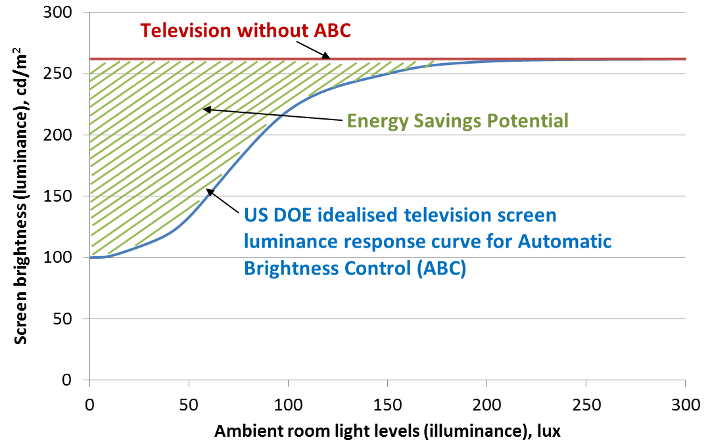
ABC is an energy saving feature of an electronic display that uses a built-in sensor to monitor light levels in the room and adjust screen brightness for viewer comfort. When light levels are low, screen brightness can be reduced which contributes to energy savings. The logarithmic response curve of human eye and an idealised screen luminance response curve were published by the US Department of Energy (Figure 1). ABC system designs that approach this ideal response is what the new ecodesign power allowance is rewarding.
Figure 1: ABC idealised curve compared to savings potential.
For the purposes of qualifying for a reduction in measured power, the regulation indicates that ‘ABC is enabled in the normal configuration of the electronic display and persists in any other standard dynamic range configuration available to the end-user’. The phrase ‘any other standard dynamic range (SDR) configuration” refers to alternative picture modes such as "Vivid", "Cinema", "Sports", etc.
ABC should be enabled by default in the “normal configuration” and in these other SDR picture modes available to the end-user.
When high dynamic range (HDR) is activated in the normal configuration, ABC does not need to be enabled to qualify for the allowance.

Mandatory user warnings, when modifying configuration parameter values
Annex I (6) provides a definition of the “normal configuration” that refers to the settings recommended by the manufacturer from the initial set up and, expectedly, should be those providing the best ‘general’ user experience. In the repealed TV Regulation this configuration was referred to as the “Home configuration”, however this term is not appropriate in the reviewed Regulation that has an enlarged scope, i.e. to displays used not only at home but also in offices and in a variety of different environments.
The “shop configuration” is also defined in Annex I (24) as the configuration usually used for demonstration of a display at retail points.
Annex II, section B.2 of the Regulation refers to set up options available to the end-user through the menu:
- Configurations, which can be either "Shop" or "Normal” configuration.
- Settings, which in TVs are usually referred to as different predetermined picture modes such as "Eco", "Vivid", "Cinema", "Sports", "Games", etc. These will include a named picture mode characterised by the parameter values for the “normal configuration”.
- Parameters, which are the options to adjust settings / configurations such as "Brightness", "Contrast", "Gamma", "Black level", where the user can set specific “values”.
A configuration can include different alternative settings, and each setting is characterised by different parameter values. Configurations and settings can be selected, parameters can be changed within a range of possible values.
The display is delivered expectedly with a specific combination of default values for each parameter part of each setting. The ‘Normal configuration’ is the specific combination that the user finds when switching on the display for the first time when unboxing and installing it. This configuration is part of the “factory settings” and the one used in compliance control activity, in particular to verify the compliance of the energy consumption when displaying the on-mode verification test (i.e. measuring the average power playing a dynamic video sequence) according to the relevant standard.
Settings and parameter values are normally modifiable by the user via the set-up menus.
The Regulation requires that a warning message and confirmation are necessary when the user makes changes, by selecting a setting different from the default one or modifying parameter values if they result in a higher power demand than in the “normal configuration”.
In case of single parameter changes, warning messages and confirmation are necessary also when the change triggers an unavoidable change in any other energy-relevant parameter. Examples of changes likely of requiring prompting of a warning:
- An increase in brightness level: a brighter level expectedly requires more light to be produced, thus a higher power consumption;
- Network standby activation: it is expected to increase the power consumption unless the network standby mode can be supported by the same power as normal standby;
- ABC deactivation: it is expected that it automatically modifies the screen luminance to an average value, thus expectedly higher when in dark conditions.
- A change to movement recognition setting: such a change is likely to extend the automatic switch to a low power mode from 1 hour to 4 hours, etc.
No user warning is required for displays listed in Article 1.3 and 1.4, such as broadcast displays, professional displays, digital signage displays or control panels.
Below you can find a flowchart detailing the required warnings and/or confirmation requests for TVs and monitors:
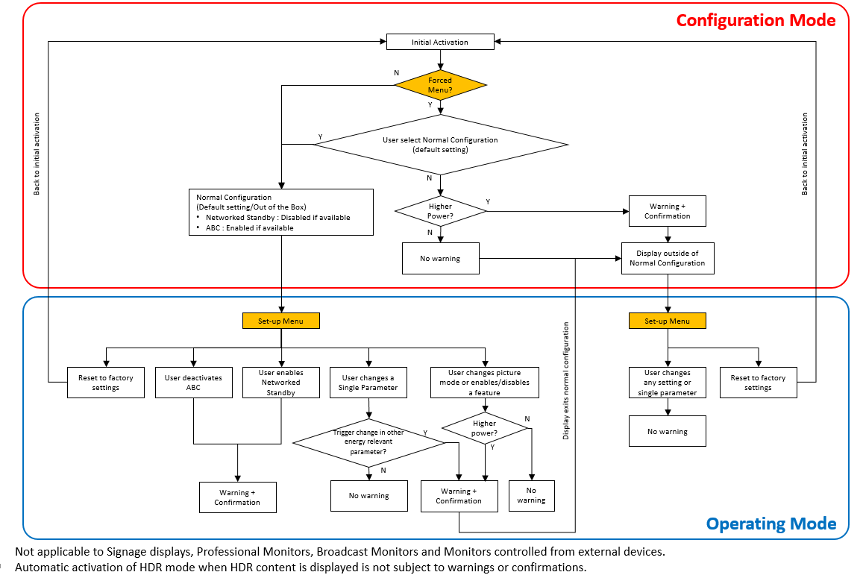

Figure 2: Example of a compliant menu and warning implementation

Some displays may lack own configuration control and, consequently, configuration, settings and parameters values are only managed by an external device, such as a computer. In such a case, as the user warnings cannot be implemented in the display and should be implemented in the controlling device, the requirements in Annex II 2. cannot apply.

Automatic powerdown in displays powering other devices
Displays including the capability of powering other devices are becoming common in some product groups, e.g. computer displays providing a USB Type-C connector for a laptop, where a single cable can deliver power to the computer (charging) and output the video and audio signal from the computer. These displays are not exempted from the requirements in Annex II C even if the power delivery function remains active. The power demand limits for off mode, standby mode or networked standby mode are not applicable only when delivering power to an external product (e.g. providing charging functions)

Network interfaces
According to Annex I (15), a ‘network interface’ (or ‘network port’) means a wired or wireless physical interface, providing network connection, through which functions of the electronic display can be remotely activated and data received or sent. Interfaces to input data such as video and audio signals, but not originating from a network source and using a network address, are not considered to be a network interface
All HDMI ports have both physical and logical addresses associated with them. Addresses are assigned based on the position of the device relative to the root, in this case a display (e.g. HDMI is effectively a tree structure, with the TV/Display defaulting to physical address 0.0.0.0. If HDMI port 1 on the display is used then a physical address of 1.0.0.0 is assigned to the device connected. If the device connected also has HDMI ports, a third device connected to HDMI port 1 of this device will be assigned a physical address of 1.1.0.0).
HDMI-CEC connections also have a logical address assigned depending on their functionality as defined by CEC specifications. This allows a HDMI-CEC to fulfil a number of functions through a single device (e.g. switching all connected devices to standby, use of the menu of another device etc.). Therefore, HDMI-CEC connections, as associated to a network address and being able to transfer network information/commands, are considered to be network interfaces or network ports.

Network standby activation
According to Section C, point 2 of Annex II to the Regulation, "Networked standby mode shall be disabled in ‘normal configuration’ of a networked television. The end user shall be prompted to confirm the activation of networked standby, if it is needed for a chosen remotely activated function, and must be able to disable it." This sentence refers to domestic televisions, with particular focus to RJ45 or WiFi network interfaces to the Internet and is intended particularly for televisions that are unlikely to be activated and operated “from” the Internet: the vast majority of users would not expect that their television is configured in such a way that, by default, somebody would be able to operate it remotely, e.g. for activating an integrated webcam or microphone or for downloading in a uncontrolled way a software update or to modify parameters. Therefore, for televisions in particular it is specified that, would the user activate the networked standby mode, then an explicit confirmation shall be requested: not only the energy consumption during all the time a television is not “on” would increase (e.g from 0,5 W to 2 W) but even security and privacy aspects are at stake.
For computer monitors, the Regulation does not mention explicitly whether the same approach shall be followed, however when the activation of the network standby results in an increase to power consumption of the display in its low power mode, a warning shall be triggered and an explicit confirmatory user action requested.
Signage displays, finally, are in general intended to be remotely activated, however the user configuring these products is expected to be an expert professional, without display warnings of the impact of his/her action, resulting in a change to the normal configuration energy consumption.

Network standby implementation
According to Section C, point 2 of Annex II to the Regulation, "Electronic displays shall provide off mode or standby mode or a networked standby mode or other modes which do not exceed the applicable power demand requirements for standby-mode […]. Automatic switch to off mode and/or standby mode and/or another mode which does not exceed the applicable power demand requirements for standby mode shall be set as default, including for networked displays where the network interface is enabled when in on mode".
Implementing only network standby mode is possible. In such a case the power consumption of the display should not exceed that of a regular standby mode (i.e. 0.5 W).
Section C, point 2 of Annex II to the Regulation does not mean that the networked standby mode cannot exceed the power demand requirement for standby-mode, but that the network standby power shall comply with the limits specified in Annex II point C (1) - Table 2.

Peak white luminance and luminance ratio
In the first paragraph of Annex II, Section B, point 3. “Peak white luminance ratio”, the peak luminance of a display product should not be less than 220 cd/m² for TVs and 150 cd/m² for monitors at 100 lux ambient light. But in the second paragraph, “If the electronic display's peak white luminance in the normal configuration is set to lower values, it shall not be less than 65 % of the peak white luminance of the display, in a 100 lux ambient light viewing environment in the brightest on mode configuration.”
It is possible to place a display product on the market if it meets just one of these peak white luminance compliance criteria i.e. the prescribed minimum peak white luminance (220/150 cd/m²) or a minimum luminance ratio (65 %).
The 65 % luminance ratio compliance requirement was devised for the television regulation (EC) 642/2009 to ensure that a TV in the factory pre-set normal setting is working at a display luminance which is suitable for the home environment and not an unrealistic luminance which has just been set to allow the TV to meet the on-mode energy requirements of the regulation. Since the publication of Regulation 642/2009, much work has been done, at international level, on measuring the ambient lighting conditions and the related user preferences in display luminance, in domestic and office environments, in particular by the US Department of Energy (DOE). For TVs, the DOE work showed that in a 100 lux ambient light environment, a preferred display luminance is around 220 cd/m². This is the recommended minimum peak white luminance factory setting for a television display in the normal/home mode for optimum user experience. In proposing this requirement, the Commission consulted with the manufacturing industry and were made aware of some display developments which allowed the use of lower peak luminance values to provide an optimum subjective viewing experience, for example, those display technologies using complex localised dynamic contrast control. The new Regulation allows the development of these new, lower measured peak luminance display technologies but has the qualification of a 65% luminance ratio to ensure that the normal setting is fit for purpose. If, a manufacturer places a TV on the market factory set to say 180cd/m² in the normal/home mode, then it is assumed that the viewing experience for the user is optimum based on the display technology. However if the luminance ratio is below 65 % then this is a clear indication that the manufacturer is suggesting a much higher preferred luminance for other viewing modes and that the product has been adjusted in normal mode to meet principally energy compliance limits and not to provide an optimum viewing experience. This approach will prompt the user to move to a brighter viewing mode that will totally negate the energy saving objectives of the Ecodesign and Labelling regulations.

Cadmium logo
The RoHS Directive sets restrictions on the use of Cadmium but its use in colour converting II-VI LEDs (< 10 μg Cd per mm² of light emitting area) for use in quantum dot displays was exempted until 30 June 2018. A request of extension was received before that date and the exemption prolonged, and is being assessed at the time of writing this document. As screen panels containing cadmium require a special treatment when disposed of as WEEE and cannot be shredded as other LCD displays, a double logo indicating “Cadmium inside” of cadmium is required both on the enclosure and inside, on the screen panel, visible once the enclosure has been removed.
A single logo “Cadmium free” on the enclosure, instead, is required for LCD screen panels not using cadmium.

Flame retardants
Components heavier that 50 grams shall be marked by specifying the type of polymer (exceptions are listed in point D.2 of Annex II). If flame retardants are used as well, a specific marking is required. As a way of example, a list of flame retardants can be found in standard ISO 1043-4 (Plastics – symbols and abbreviated terms – Part 4: Flame retardants): according to this standard, a content higher than 1 % by weight in homogenous material, the plastic component is considered to contain flame retardants.
The requirement set in Annex II. Section D point 4. to the Regulation applies to any halogenated flame retardant (HFR). It does not apply to non-halogenated flame retardants. The restriction in intended to cover “circular economy” aspects, i.e. to streamline the recycling of plastics in such a way that the recycled yield from enclosure and stands of future products (i.e. all those Displays placed on the EU market from start of application of the Regulation) can be placed on the EU market as Post Consumer Recycled (PCR) polymers and so that a smaller fraction is incinerated (compared to the situation when the Regulation was assessed). The requirement, thus, does not overlap or replace existing regulations on hazardousness but, on the contrary, complements them, by tackling upstream issues that are now encountered downstream (i.e. by the WEEE recycling industry). .
The restriction on the use of halogenated flame retardants only covers the enclosure and stand. Halogens are not restricted in other components or parts, assuming that recyclers separate the two biggest plastic parts, the enclosure and the stand, before possibly shredding the remaining parts.
A single restriction is set for any HFR because, although separation of any halogenated plastic from non-halogenated ones is feasible and currently performed by the WEEE recycling industry, at least with the state of art available at the time the Regulation was assessed, no affordable technology is available to distinguish, in the plastic yield of plastic flakes resulting from shredding process, which specific compound is used, restricted or not.
Halogens that classify as a polymer according to Regulation (EC) No 1907/2006 (REACH) are not restricted by this Regulation.

Repair and spare parts
In accordance with Annex II part 5, manufacturers, importers or authorised representatives must make available certain spare parts for at least 7 years after placing the last unit of the model on the market.
As for availability of software/firmware updates, the Regulation does not require this to be documented on a website, however good practice would be to document such availability in the documentation provided. The timing for the number of years starts ticking from the specific date set in the specific field in the product registration database (aka EPREL), thus the manufacturer has an interest in setting such a value as soon as it is known.

Availability of capacitors, batteries and connectors as spare parts
Only electrolyte capacitors (height > 25 mm, diameter > 25 mm or proportionately similar volume) as defined in indicated in point 1 of Annex VII to Directive 2012/19/EU on WEEE are to be considered as spare parts to be provided by manufacturers.
Only proprietary batteries should be provided as spare parts, i.e. battery cells irreversibly packaged with specific, non standardised shapes, insertion clips, connectors, etc. Standardised battery cells are generic parts, widely available to any repairer, therefore there is no need for manufacturers to provide these for repair purpose.

Repair information availability
The Regulation takes into account that repair information may only be accessible by professional repairers and sets minimum requirements on how to make it available. If the repair information is freely available in a free-access website, there is no obligation for the manufacturer to manage a registration process for professional repairers.

Spare part availability verification process
Maximum delivery time of spare parts is set at 15 working days (i.e. normally 3 weeks), considering that parts may have to be delivered from outside the EU. In situations where the manufacturer takes all reasonable steps that in the normal course would result in delivery, within 15 days of receiving the order, but the package containing the part is lost or unexpectedly delayed by the post or courier in charge of the delivery, this is not considered as non-compliance if the manufacturer can provide evidence that the failure is attributable to events beyond its delivery to the parcel delivery service.
Sub-assemblies qualify as one spare part if, for reasons pertaining to the quality, functionality or integrity of the product, the spare part listed in Annex II D. section 5 point (1)(a) needs to be integrated in a larger subassembly.

Removability of batteries and accumulators
Article 11 of the EU Battery Directive (Directive 2006/66/EC) states that the provisions on removability of batteries and accumulators do not apply where, for safety, medical or data integrity reasons, continuity of power supply is necessary and a permanent connection between the appliance and the battery or accumulator is required.
Annex II – section (d) – point 1 on the design for dismantling, recycling and recovery indicates that joining, fastening or sealing techniques cannot prevent the removal, using commonly available tools, of batteries and accumulators.
After the start of application of this Regulation, a permanent connection between the appliance and the battery or accumulator is still permitted under the conditions indicated in Directive 2006/66/EC.

Commonly available tools
Requirements on design for dismantling, recycling and recovery include that use of commonly available tools shall permit the removal of a number of components that need to be taken apart before displays are shredded at recycling plants. No definition has been set for these tools, but they have to be intended as publicly available for purchase by any individual or business without restriction and a cost proportionate with the intended purpose.

Design for outdoor use
Displays specifically designed for outdoor use are sealed (potted) to ensure the proper IP rating. This means electronics may be embedded in a silicone layer to prevent moisture to come into contact with the electronics. As a consequence, PCB assemblies cannot be easily removed. Tiles and controllers can be instead removed using standard tools from their mounting structure to facilitate repair and modularity, therefore the necessity for sealing does not impact reparability Irreversible sealing techniques may also be necessary for safety and durability of specific products. In these conditions, displays such as for outdoor use can be considered compliant with the Regulation under the condition that the technical documentation provides relevant technical justification related to why the sealing has been used, as well as instructions on how to disassemble or dismantle the display for repair.

Software and firmware-related requirements
Section E, Annex II sets requirements on availability of software/firmware updates.
The information related to the minimum guaranteed availability of software and firmware updates, as well as availability of spare parts and product support shall be indicated, free of charge, in the product information sheet, when placing on the market the first unit of a model or of an equivalent model.
The latest available version of the firmware shall be made available to third parties dealing with professional repair and reuse of electronic displays (including third party maintenance actors, brokers and spare parts providers) free of charge, or at a fair, transparent and non-discriminatory cost. The latest available version of the firmware shall be made available for a minimum period of eight years starting after the last unit of a certain product model is placed on the market.
The latest available security update to the firmware shall be made available free of charge to third parties dealing with professional repair and reuse of electronic displays (including third party maintenance actors, brokers and spare parts providers). The latest available security update to the firmware shall be made available for a minimum period of eight years starting after the last unit of a certain product model is placed on the market.
As for spare parts, also for software/firmware updates, the timing for the number of year’s starts ticking from the specific field in the product registration database (aka EPREL), thus the manufacturer has an interest in setting such a value as soon as known.

Technical documentation for Ecodesign
The technical documentation for ecodesign shall contain all the elements in the order mentioned in Annex VI of the Energy Labelling Regulation, together with:
- the reason why certain, if any, plastic parts are not marked
- the list of all equivalent models, including the model identifiers.

Verification procedure
Annex IV establishes a verification procedure of compliance with the requirements in the regulation. This verification procedure shall be carried out in the “normal configuration” of the display, i.e. in the condition in which the values for off, standby, networked standby and on mode are measured” and requirements on them are satisfied (e.g. networked standby disabled in televisions). Furthermore, Annex II A.1 of the regulation additionally states that P_{measured} is the measured power in on mode in Watts in the normal configuration”.

Regulation 2019/2021

Provision of the new energy label and display
Products placed on the EU market from 1 March 2020 will have to be displayed, both in bricks & mortar shops and on e-commerce web sites, with the new energy label as in Annex III of the Regulation. Dealers will have two weeks to manage the replacement of the old label with the new one for all products already on display as of February 28, unless the products are discontinued (i.e. not placed on the market anymore from March 1). To assure compliance, manufacturers shall provide both the old and the new label in the box from 1 November 2020.
The obligation to print the new energy label on the packaging of the display or to put a sticker on it, on the contrary, only starts applying from 1 March 2021, so there is no need to start earlier. Moreover, as the new label should be not be displayed before 1 March, it may be advisable to start applying the requirement by using stickers, rather than printing the label (in colour) on the box. A label printed in black and white on the box of the product is not foreseen but a coloured sticker of the label is permitted (no black & white version of the label is presented in the Regulation).
Electronic displays presented at trade fairs that are prototypes or that are production models but not yet placed on the EU market do not have tof displaythe label. However products put on sale at trade fairs shall bear the label.

Indication of Energy Class and Range of classes available on the label
The Energy Class and range of classes available on the label have to be indicated in marketing materials featuring displays that have already been placed on the EU market, or which are being made available for purchase in the EU. Marketing materials featuring displays that are announced but not yet placed on the market or made available for purchase in the EU are not subject to the obligation.
Products that are covered, for the first time, by an energy label starting the 1st of March 2021 (e.g. computer monitors and signage displays), no obligation applies in respect to the provision of the new label from 1st of November (and obviously, no obligation applies for the double label).
Similarly, for these products newly in scope the interdiction of selling old stocks without the new label beyond the 9 months allowed by the regulation does not apply. For the purpose of stock management, voluntary provision of the new label in the box and on the packaging of such products before the 1st of March 2021 is considered acceptable.
for products that are no longer placed on the market after 1st of March 2021 it is not mandatory to provide the new label. However, as stated in the Energy Labelling framework, products can only be sold with the old label for 9 months after the entry into force of the new label (i.e. until 30 November 2021).
The regulation does include provisions about the timeline during which manufacturer websites and retailer online shops need to be modified in order to display the new labels and meet all the new online requirements. In order manage this transition, the 14 working day period referenced in the Energy Labelling framework should be cosidered as a transition period to replace the old labels with the new ones in online environments.

Correction factor for signage displays
The correction factor for signage displays only applies when the peak luminance is higher than 500cd/m². When the peak luminance is lower than 500cd/m², it does not apply.

Off mode declaration in product fiche and technical documentation
For displays that do not have an off switch and mode, the technical documentation and parameter entered in the product registration database (EPREL) shall indicate ‘N/A’.

ABC-related parameters in the technical document
Table 5 of Annex VI (Technical parameters) reads "Measured on mode power at 100 lux ambient light at the ABC sensor" whilst row 9 reads "Average on mode power demand of the electronic display at an ambient light intensity, measured at the ABC sensor of the electronic display, of 100 lux". They refer to the same value.

Consequently, also from the Labelling Regulation.
Or, from a different perspective, being too lenient with the biggest ones
TECH 3320 - USER REQUIREMENTS FOR VIDEO MONITORS IN TELEVISION PRODUCTION available from https://tech.ebu.ch/docs/tech/tech3320.pdf
RoHS, REACH and POP legislation restrict the use of a number of different halogenated compounds. For example, Annex II of Directive 2011/65/EU (RoHS), sets a residual limit of 0,1 % (by weight in homogeneous materials) for PBB and PBDE. Similarly, Annex XVII of Regulation (EC) 1907/2006 (REACH) restricts DecaPDE and requires prior authorisation for HBCDD. Halogenated flame retardants such as Penta BDE, OctaBDE, DecaBDE, HBCD are also restricted under Annex I of Regulation (EU) 2019/1021 on persistent organic pollutants (POP) and more are being scrutinised for restriction under different legislations.
i.e. the “End of placing on the market date”.
Industry requests this issue to be addressed via an amendment. Justification and detailed amendment proposal can be found in Annex I A, p. 2
Redesigning these special-purpose products without the use of sealing techniques would seriously impact product safety and durability. Industry therefore requests an exemption from the removability requirement for electronic displays intended for outdoor use.
IP (or "Ingress Protection") ratings are defined in international standard EN 60529. They are used to define levels of sealing effectiveness of electrical enclosures against intrusion from foreign liquids, dirt, moisture, etc.
i.e. the “End of placing on the market date”.
Industry requests this issue to be addressed via an amendment. Justification and detailed amendment proposal can be found in Annex I B, p. 3
Industry requests this issue to be corrected via an amendment.

