INDIA-SWEDEN COLLABORATIVE INDUSTRIAL RESEARCH & DEVELOPMENT PROGRAMME 2020
COMMON APPLICATION FORM

Application Details
How to complete and submit this form
Please check the Request For Proposal (RFP) – Terms, Conditions and Guidelines for Application before completing this form, it will provide valuable information and tips on how to answer each section.

Please ensure you submit your application Online and include all required documentation for the relevant stage of the RFP. Details of any additional documentation required (includes appendices & documents) are included in the Request For Proposal (RFP) – Terms, Conditions and Guidelines document.
Additional documents may be required for applicants - for detailed guidelines and instructions, refer to the Request for Proposal (RFP) document.
Do not provide narration of the technicalities involved. Only provide the quantitative description that can be quantified and measured. Please provide concise answer.
Request For Proposal
Project title:
Project timescales | Estimated start date: | Duration: | months
Contact Information - Lead Project Participants (has to be from Industry mandatorily)
Indian Project Coordinator (IPC) name:
Swedish Project Coordinator (SPC) name:
Project Leads contact details:

 |  | India (Lead) | Sweden (Lead)
 | Name of the Organisation
 | Parent Organisation
 | Contact Person
 | Department
 | Position/Designation
 | Registered Address of the Organization
 | Corporate Address of the Organization
 | Project Location
 | E-mail Address
 | Alternate Email Address
 | Office Phone Number
 | Cell Phone Number
 | Technology Sector of the organization
 | Technology Subsector of the organization
 | Registration number of the organization
 | Date of registration of the organisation
 | No. of Employees
Contact Information – Other key participants/co-investigators from industry, academia, or government (wherever applicable)

Sweden/Indian Partner Details (Separate Table for Each Partners)

Name of the Partners Organization
Contact Person
Department
Position/Designation
Registered Address of the Organization
Corporate Address of the Organization
E-Mail Address
Alternative Email Address
Office Phone Details
Cell Phone Details
Website of the Organization

1. Executive Summary of Project
Section 1
- A brief Overview & Objective of the entire project that describes the product/technology/
service that you intend to develop in partnership with all partners (both India & Sweden) mentioning the key issues to be addressed and related risks and mitigation.

Section 2
- Snapshot of the Project Budget (total budget and total grants applied for).

Maximum 1500 words (including Graphs, Pictures, Tables in form of Images)

2. Background and Motivation, Project Description, Innovation Proposed & Associated Challenges
Sub-section 2.1 Background and Motivation
- Describe the Background and Motivation and market need to justify the need of the proposed project concept/ Innovation (endorsement / supporting letters by large consumers / users will be appreciated).

Sub-section 2.2 Project Description
- Detail of the entire project idea that describes the product/ technology/ service that you intend to develop in partnership with all partners (both India & Sweden) along with Flow Charts and related approach plan.

Sub-section 2.3
Scope of Work (in Tabular Form)
- Provide detailed Scope of Work and related sub-activities under each broad heads of Scope of Work
*Please provide this information as per the below table.

Sub-section 2.4 Innovation proposed
- Specify and explain the degree of Innovation and Technology Readiness Level (TRL) of your proposed project concept in the context of the current Technologies available in the market.
*Kindly refer to the TRL Chart below

Sub-section 2.5
Proof of Concept and Targeted Market
- Provide the necessary details of any Proof of Concept or Requisite level data captured/available for taking up this proposed project.
- Specify and explain if there is any background patent available with any of the project/consortium partners.
- Describe the potential market targeted through the proposed project concept.
Sub-section 2.6
Technical Challenges & Mitigations
- Discuss the possible technical challenges involved in the proposed project concept and its mitigation plan.

*Please explain all sub-sections in Maximum 250 words each.
*you are requested to insert Graphical, Pictorial and Tabular representation where applicable (to be inserted in form of picture format) of your concept / explanation / narration in all above sections for comprehensive and better understanding of your project concept / approach and other modalities.

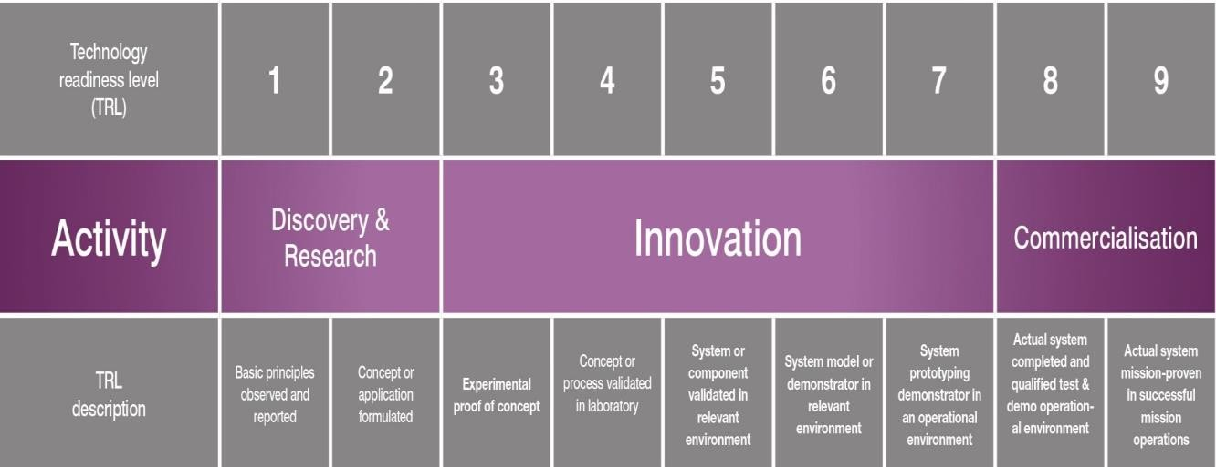
For Sub-section 2.3 the following table needs to be filled:

S. No. | Broad Scope of Work | Sub-Activities

TRL Chart will go as reference.

3. Partners/Sub-contractors Roles & Responsibilities, Project
Milestones and Deliverables
This section should describe the following important components:

- Key Roles & Responsibilities of each Partner in the context of the agreed Scope of Work, Key Milestones and related Timeline (as per the tabular format attached below)
- Expected IP/results to be generated through this proposed project & details of the agreement on IP sharing mechanisms (maximum 300 words)
- Please fill out the table below

S.No | Broad Scope of Work | Sub-Activities | Deliverables | Duration | Milestones | Responsible

2. IP Sharing Arrangement

4. Project Teams: Indian & Swedish
- This section consists of a short one or two sentence bullet describing each of the core members of the team.
- Each bullet should provide the name of the Team member, their role in the organization, and highlights of their relevant skill or career experience
- Discuss the entire team as a whole (including: the balance of the partnership; key complementary qualifications of partners; and added value through cooperation such as ability to share risks, costs, know-how, and benefits)
- If you have worked with the partner(s) identified (IPC or SPC) in the past, please provide details of such engagement(s).
S. No. | Name | Designation, Organisation | Qualification/  Experience | Principle Area of Focus in this Project

Entire Team

(Maximum 250 words for this section)

5. Financial Statement

Table Costs
Budget  and Duration | Budget  (€ / INR) |  | Year-1 (2022) |  | Year-II (2023) |  | Total
 |  | Cost Category | India | Sweden | India | Sweden | India | Sweden
 |  | Capital Cost (Non-Recurring)
 |  | Equipment (Minor Research)
 |  | General Cost (Recurring)
 |  | Research Manpower
 |  | Consumables
 |  | Contingencies
 |  | Travel (Domestic)
 |  | Travel (International)
 |  | Other cost (must be specified)
 |  | Overhead/ Project Management
 |  | Total

Table Financing
Financial Source | Year-1 (2022) |  | Year-II (2023) |  | Total
 | India | Sweden | India | Sweden | India |  | Sweden
Cash from project partners
Other public financing
Other private financing
Applied financing from Call
Total
Partner 1/Partner 2/Partner3/… | Year-1 (2022) |  | Year-II (2023) |  | Total
Name of partner: | India | Sweden | India | Sweden | India | Sweden
Cash
Other public financing
Other private financing
Applied financing from Call
Total

Statement of Cooperation & Certification

The form must be co-signed by at least one industry participants from each Sweden and Indian side.

The participants signing below intend to co-operate within the project as described in this form with the aim of realizing the technical developments as set forth. In addition the participants have or will put in place, a formal cooperation agreement (including IP arrangement) prior to start of the Project.

 | Indian Project  Lead | Swedish Project  Lead | Partner 1  (if any) | Partner 2  (if any)
Name of Organization
Signature (Authorized
Signatory)
Name of Signatory
Designation of Signatory
Seal of Organization
Place
Date

